SOUTHERN METHODIST COLLEGE
A Bible College

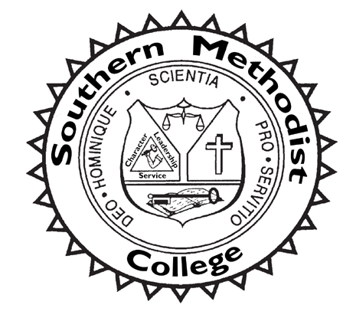
2022 – 2023 Catalog & Student Handbook

541 BROUGHTON STREET
ORANGEBURG, SOUTH CAROLINA 29115
Telephone (803) 534-7826
E-mail: smcinfo@smcollege.edu
Web page: www.smcollege.edu
Fax (803) 534-7827
Updated – November 1, 2022

Preparing men and women for Christian life and service

TABLE OF CONTENTS
INTRODUCTION 3
COLLEGE PROFILE 5
BIBLICAL FOUNDATIONS: A DOCTRINAL STATEMENT 7
MISSION STATEMENT 9
MISSION STATEMENT 9
CODE OF CONDUCT 12
CAMPUS LIFE 14
ADMISSIONS INFORMATION 15
FINANCIAL INFORMATION 18
FINANCIAL AID 21
ACADEMIC INFORMATION 24
ACADEMIC PROGRAMS 29
COURSES OF INSTRUCTION 36
BOARD OF DIRECTORS 46
PERSONNEL 47
TELEPHONE DIRECTORY 49

INTRODUCTION

THE COLLEGE SEAL
The College seal, symbolizing the focus of Southern Methodist College, is keyed to the Holy Bible as the foundation of all learning. The cross represents the risen Christ and His church. The three facets of character, leadership, and service are the personal attributes to be developed as strengths in each student. The scale signifies the balance in a Christian education between the academic and the spiritual life.
The Latin motto Scientia pro Servitio Deo Hominique, “Knowledge for Service to God and Man,” expresses the goal of the College to prepare men and women for Christian life and service.
As Jesus “increased in wisdom and stature, and in favor with God and man” (Luke 2:52), the desire of Southern Methodist College is that each student discover God’s will, grow in wisdom and strength, and learn to serve both God and man.

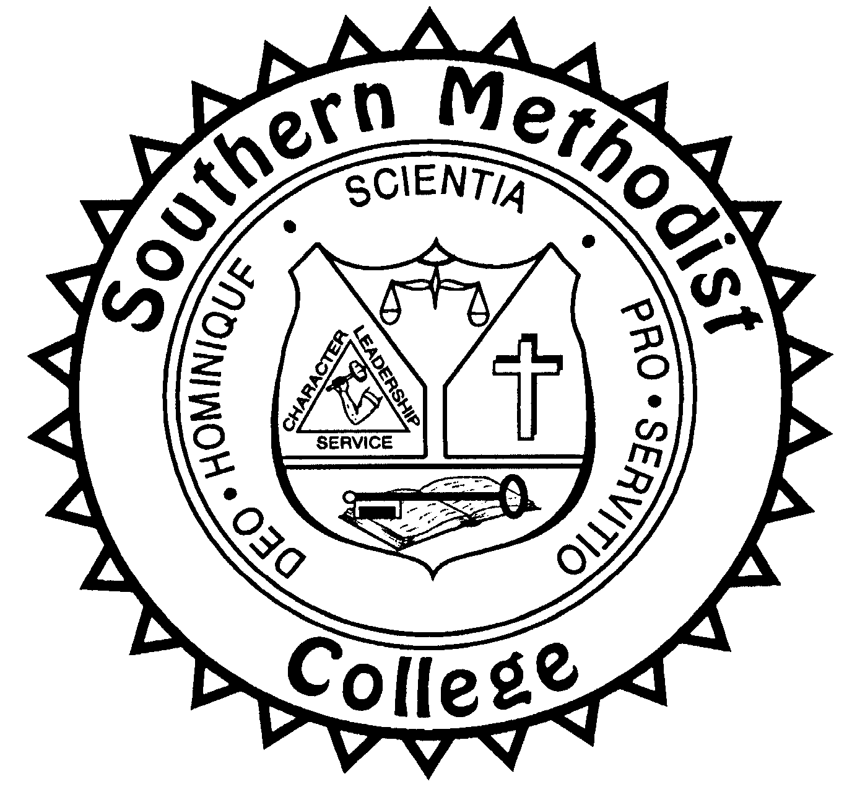

COLLEGE CALENDAR

Fall Semester 2022
August 2 …………… Registration for Fall Semester Begins
August 16 …………...Fall Semester Term 1 Begins
September 13………..Board of Directors
October 10 …………..Fall Semester Term 1 Ends
October 10 ………….Deadline for Submission of Term 1 Work
October 11-17 ……….Fall Break
October 18 …………..Fall Semester Term 2 Begins
December 12 ………..Fall Semester Term 2 Ends
December 12 ………..Deadline for Submission of Term 2 Work
Spring Semester 2023
December 13 ….…....Registration for Spring Semester Begins
January 3 ……….…..Spring Semester Term 1 Begins
TBA………...............Annual Fellowship Dinner, 6 P.M.
TBA............…….…...Board of Directors
February 27 …….…...Spring Semester Term 1 Ends
February 27 ………..Deadline for Submission of Term 1 Work
Feb. 28-March 6 ........Spring Break
March 7….………….Spring Semester Term 2 Begins
May 1…….…………Spring Semester Term 2 Ends
May 1 …….………...Deadline for Submission of Term 2 Work
Summer Semester 2023
May 2 …….…………Registration for Summer Semester Begins
May 16 …….………..Summer Semester Term Begins
July 10……….………Summer Semester Term Ends
July 10 …….………..Deadline for Submission of Summer Term Work
Jul. 11 – Aug. 14 ……Summer Break

COLLEGE PROFILE

AN INVITATION
Southern Methodist College invites prospective students to pursue a Christian college education which prepares men and women for Christian life and service. Our model is the Lord Jesus Christ, who "...increased in wisdom and stature, and in favor with God and man" (Luke 2:52). These four facets of growth and development provide a firm foundation and basis for ministry. College life and activities encompass a curriculum that offers academic excellence and opportunities for Christian service within a Christian environment on-line and on-site conducive to personal and interpersonal growth.
Southern Methodist College does not discriminate on the basis of gender, age, race, disability or handicap, veteran status, nationality, or ethnic origin in administration of its educational policies, admissions policies, scholarships, employment, or other school-administered programs. This position is a Biblical conviction based on Galatians 3:28: "There is neither Jew nor Greek, there is neither slave nor free, there is neither male nor female; for you are all one in Christ Jesus" (NKJV).

PROFILE
Southern Methodist College, an institution of the Southern Methodist Church, is a private, four-year, co-educational institution lending itself to Christian living and academic pursuits. Students from different denominations and different countries are represented in the student body.
The College is located in the historic city of Orangeburg, South Carolina, forty miles southeast of Columbia and eighty miles northwest of Charleston. The fifty-acre campus at 541 Broughton Street occupies the lands and residence of the former Frederick A. Adden estate, given to the Southern Methodist Church in 1961 by the late Mrs. Adden for the purpose of developing the College on the site. The Lynn Corbett Library (under renovation) is located at 425 Broughton St. The campus is owned and managed by The Southern Methodist Church.
Southern Methodist College is non-accredited. The College operates under charter from the State of South Carolina and by exemption from the South Carolina Commission on Higher Education in offering degrees in Biblical Studies and Religious Education. The College is a member of ACSI, the Association of Christian Schools International.
The present academic program of the College is offered through the on-line venue. A limited number of courses are offered on-campus to supplement the on-line program and to provide courses of community interest.

HISTORY
The Southern Methodist Church, formed in Columbia, South Carolina, on January 14, 1939, as the continuing body of the Methodist Episcopal Church, South, later established Southern Methodist College as an institution of the Church on January 26, 1956, in Greenville. Recognizing the great need for a strong Christian education to prepare Christian leaders and workers, Church leaders established Southern Methodist College as a center of highest academic standards and Christian culture where men and women would receive education and training to go forth as Christian leaders rendering service throughout the world for the glory of God.
The College moved to Aiken in 1958, and again to Orangeburg in 1961 at the invitation of Mrs. F.A. Adden, who desired to see her property be used in providing men and women with a Christian based education.
The Southern Methodist Church established the College as a Bible college to provide a distinctively Christian post-secondary education committed to the ideals, the doctrinal convictions, and the ethical practices of the sponsoring denomination.

FACILITIES
Adden Hall, the stately Victorian mansion built in 1903 by Mr. Frederick A. Adden as a wedding present to his new bride, contains 6,000 square feet of floor space and houses the President's Office, the Registrar's Office, Southern Methodist Church offices, and an information center for visitors.
Lynn Corbett Library, named for the Rev. W. Lynn Corbett, past president of the Southern Methodist Church and former administrator of the College, contains a collection of volumes to support the curriculum, open stacks, reading and study areas, the Methodist Room, and a help desk. The library, supported through gifts, memorials, and endowments, provides services for students of the College, alumni, pastors, and other members of the public interested in research. The Methodist Room contains a collection of various resources for the study of Methodism and Southern Methodism in particular. The Library is located at 425 Broughton Street and is presently under renovation.

The following buildings are located on the College campus for use by Southern Methodists and like-minded groups under the administration of the Southern Methodist Church Ministries Office: Gamble Hall, Terry Hall, Huggins Field House, Felkel Center, Carrier Conference Center, and a Maintenance Building.

Adden Hall

BIBLICAL FOUNDATIONS: A

DOCTRINAL STATEMENT

SCRIPTURE
The Holy Scriptures contain all things necessary to salvation so that whatever is not read therein, or is not proved thereby, is not to be required of anyone, and is not to be believed as an article of faith, or thought requisite or necessary to salvation. The sixty-six canonical books of the Old and New Testament constitute the Holy Scriptures. The Scriptures are the inspired and infallible written Word of God, fully inerrant in their original manuscripts, and the final authority in all matters of faith and conduct.

CREATION AND HISTORICITY
The Genesis account of creation and early human history is to be accepted literally. God created man, animals, and plant life, and none of these were the result of an evolutionary process. God completed the creation process in six days and rested on the seventh day. God created man in His image and likeness, making man a unique creation and distinct from the rest of His creation.

THE TRINITY
There is one living and true God, eternally self-existent; and in the unity of the Godhead are three persons of the same essence, attributes, and power: the Father, the Son, and the Holy Spirit.

THE FATHER
God the Father is infinite Spirit, sovereign, eternal, and unchangeable in all of His attributes. He is worthy of honor, adoration, and obedience.

JESUS CHRIST
Jesus Christ is the only begotten Son of God, conceived by the Holy Spirit, born of the Virgin Mary, very God and very man, two whole and perfect natures; He truly suffered, was crucified, died, was buried, and arose bodily and victoriously over sin and death.

SALVATION
Jesus Christ is the only and the sufficient mediator between God and man, who by the sacrifice of Himself on the cross, provides atonement for the sins of the human race. Whoever believes on Him as personal Savior will be pardoned, forgiven and saved, and will have direct access to God through prayer.

THE HOLY SPIRIT
The Holy Spirit is of one essence, majesty, and glory with the Father and Son, very and eternal God. He operates upon the sinner to bring conviction and gives assurance to the believer that he has passed from death to life. He regenerates, sanctifies, indwells, guides, instructs, and empowers those who yield to Him. He gives spiritual gifts to believers and enables them to live a holy life.

MAN
Man was created in the image of God, but through transgression fell from that holy state and thus incurred spiritual death and depravity. As man is the offspring of Adam, the nature of man is continually inclined to evil. He cannot turn and prepare himself by his own natural strength nor through good works without the prevenient grace of God in Christ; but by the grace of God working in man and with man, he may by faith in the merit of our Lord Jesus Christ and repentance for sin be regenerated by the Holy Spirit and be justified, so that he is delivered from the power of sin and enabled to love and serve God with the will and the affections of the heart.

ETERNAL LIFE
There is a conscious existence after death, either in heaven, an everlasting happiness in the presence of the Lord for the saved, or in hell, an everlasting torment separated from the very presence of God for all who reject salvation by grace through faith in the Lord Jesus Christ.

THE SECOND COMING
After Jesus Christ arose from the dead and appeared on earth in a glorified body, He ascended into heaven and is seated at the right hand of God to make intercession. He will return literally, bodily, and personally to earth at God's appointed time to judge and purge sin, to establish His reign on earth, and to fulfill His purposes in creation and redemption. This blessed hope of His Second Coming is a powerful incentive to holy living.

THE CHURCH
The universal church is all true believers regardless of church affiliation. The visible church is ordained as a congregation of the faithful in which the Word of God is preached, the sacraments of baptism and the Lord's Supper are duly administered, believers are built up in the faith, and the outreach ministry of the Great Commission is duly practiced.

SATAN
Satan is a literal, personal being who is opposed to God's work. He is the Author of evil, the Tempter of man, the Accuser of the saints, and the power behind all apostasy.

HOLINESS
God is holy by reason of His glory, His purity, and His exaltation above others. His purpose in the believer is to purify the heart from sin and to renew His own moral image. By faith in Christ the believer is pardoned from the guilt of sin. In sanctification the Holy Spirit continues that transforming work of grace begun in regeneration, enabling the believer to live as one separated to God, thereby loving Him with his whole being, and separated from the sinful conduct of the world, thereby fulfilling the command, “Be ye holy, for I am holy.”
This doctrinal statement was established by the Board of Directors. An expanded statement of Biblical foundations is in the Southern Methodist Discipline and is available upon request.

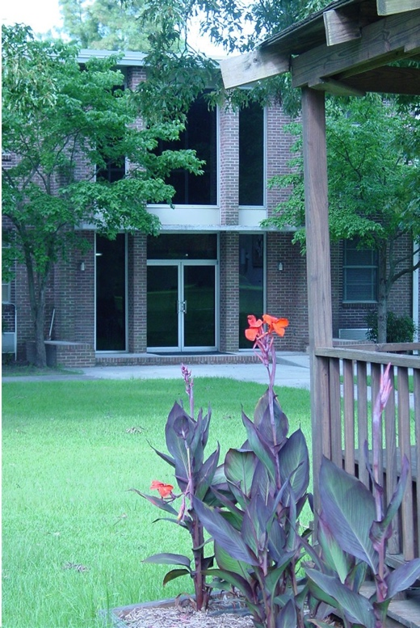

STATEMENT ON MARRIAGE, GENDER, AND SEXUALITY
We believe that God wonderfully and immutably creates each person as male or female. These two distinct, complementary genders together reflect the image and nature of God. (Genesis 1:26-27). Rejection of one’s biological sex is a rejection of the image of God within that person.
We believe that the term “marriage” has only one meaning: the uniting of one man and one woman in a single, exclusive union, as delineated in Scripture (Genesis 2:18-25). We believe that God intends sexual intimacy to occur only between a man and a woman who are married to each other. (1 Corinthians 6:18; 7:2-5; Hebrews 13:4).
We believe that God has commanded that no intimate sexual activity be engaged in outside of a marriage between a man and a woman. We believe that any form of sexual immorality (including adultery, fornication, homosexual behavior, bisexual conduct, bestiality, incest, and use of pornography) is sinful and offensive to God. (Matthew 15:18-20; 1 Corinthians 6:9-10).
We believe that in order to preserve the function and integrity of Southern Methodist College, and to provide a biblical role model to the Southern Methodist College community, it is imperative that all persons enrolled in Southern Methodist College, employed by the College in any capacity, or who serve as volunteers, agree to and abide by this Statement on Marriage, Gender, and Sexuality (Matthew 5:16; Philippians 2:14-16; 1 Thessalonians 5:22).
We believe that God offers redemption and restoration to all who confess and forsake their sin, seeking His mercy and forgiveness through Jesus Christ (Acts 3:19-21; Romans 10:9-10; 1 Corinthians 6:9-11).
We believe that every person must be afforded compassion, love, kindness, respect, and dignity. (Mark 12:28-31; Luke 6:31). Hateful and harassing behavior or attitudes directed toward any individual are to be repudiated and are not in accord with Scripture nor the doctrinal statement of Southern Methodist College.

MISSION STATEMENT

PURPOSE
Southern Methodist College provides post-secondary education with a Biblical foundation that prepares students to think, live, and serve as effective Christians in the church and in society. The overall structure of the College programs and activities seeks to develop general education, intellectual abilities, Bible knowledge, spiritual maturity, and ministry skills through the processes of academic instruction, experiential learning, and career development.

OBJECTIVES

The Southern Methodist Church recognizes and accepts the duty and obligation of maintaining institutions of higher learning for the promotion of a distinctively Christian culture. Southern Methodist College, as an institution of the Southern Methodist Church, shall seek these goals as mandated in The Discipline of the Southern Methodist Church (paragraph 507):
1. To maintain academic standards that are generally accepted in the educational field;
2. To infuse into the whole educational process, including instruction and all extra-curricular activities the truth in this period of the gospel of Jesus Christ;
3. To provide instruction and training in religion through the teaching of the Bible, the history and principles of Christianity, and application of Christian principles to personal and social life;
4. To cooperate with other agencies of the church in training for service in the church and community;
5. To initiate and foster agencies that will contribute to the development of the spirit and atmosphere in the institution conducive to the highest type of Christian character and Christian living;
6. To cultivate among its students interest in a local church and to encourage and train them for such a work.
Mindful of its heritage and mandate, Southern Methodist College provides each student the opportunity to integrate these principles by implementing the following objectives. Graduates of Southern Methodist College should be able to:

Spiritual
1. Articulate a foundational knowledge of Bible content and doctrine;
2. Continue to build upon their foundational knowledge of Scripture as independent self-learners of the Bible, using the historical-grammatical method of interpreting Scripture to develop a personal theology and a Biblical philosophy of life;
3. Become increasingly like the Lord Jesus Christ with the desire to know Him and apply Biblical standards of Christ-like living in spiritual, social, and physical dimensions of life;
4. Embrace a Christian ethic and lifestyle in ministry and interpersonal relationships;
5. Discern their major spiritual gifts and natural abilities, and demonstrate an understanding and refinement of ministry skills in order to fulfill God's purpose for their lives;
6. Promote and defend the Christian faith through appropriate witness to unbelievers;
7. Communicate persuasively the Biblical message and minister effectively in Christian and non-Christian settings;

Educational
1. Demonstrate academic excellence as self-learners through broad reading habits, and through critical thinking skills which challenge concepts, investigate alternative viewpoints, and form personal conclusions;
2. Evidence a Biblical world view that stresses Biblical truth as the foundation for all learning and provides a framework for interpreting, integrating, and assimilating information from various sources;
3. Integrate cognitive content into personal value systems and practical applications;
4. Communicate effectively in oral and written English;
5. Demonstrate self-understanding as the foundation for understanding individuals, institutions, or cultures in general;
6. Develop vocational knowledge and skills for competent employment in a specific occupation.
7. Discern individual and societal problems and apply Biblical solutions.
Southern Methodist College seeks to accomplish its objectives by:
1. Enriching the quality of spiritual life in the College and community by providing Biblical instruction, cultural programs, short courses, and workshops.
2. Promoting holiness in all academic and non-academic activities.
3. Offering programs that stress quality education designed to meet the changing needs of the Christian community and society.
4. Maintaining a curriculum that accepts the truth that the Bible is the inerrant verbal revelation of God and which correlates the academic courses to Biblical principles.
5. Maintaining continuing education programs and services for the church and the community.
6. Offering programs at an affordable cost and providing financial aid to students who qualify.
7. Designing the curriculum of the College to meet individual needs and promoting opportunities for personal growth, socially, academically, and professionally.
8. Providing academic counseling and other supportive services to assist the student academically.

PHILOSOPHY OF EDUCATION

The College adamantly holds a position of Biblical Theism and bases its educational philosophy on the belief that all knowledge comes from God. All truth is God's truth whether it be found in His Word or in His world, whether the student comes to know this truth through special revelation or natural revelation.
Therefore, Southern Methodist College believes that a strong foundation in liberal arts is essential to the well-rounded Christian education and that the Christian student must seek to understand the world and culture in which he will minister. Acquaintance with non-Biblical subjects from a Christian worldview equips the student to understand himself and his society.
Christian education must operate from the premise that the Bible is God's unique revelation to man and contains the answer to the human predicament; therefore, Biblical principles permeate every subject and every phase of college life as the primary focus of the educational program in which the content of all courses must be in harmony with the Word of God and all teaching must submit to the authority of the Bible as the infallible, inerrant Word. Any secular teaching which contradicts the Bible is not held as truth.
Furthermore, Southern Methodist College recognizes that the Holy Spirit is the ultimate Teacher. The faculty acknowledges their dependence on Him for strength and wisdom. They also recognize that He alone can move within the heart of the student to bring understanding and conviction.
The College further believes that Christian education must be rooted in objective reality and absolutes as opposed to relativism and that any true principles of teaching will reflect the teachings of Scripture. Christian education must embrace the physical, emotional, social, and spiritual, as well as the academic needs of the individual, through a curriculum designed to meet the needs of the whole person.
Through practical ministry internship programs, students gain the experience of applying classroom principles to their chosen area of service. Southern Methodist College encourages the student to develop Biblical ideas and values through the integration of his college education with self-study and personal experience.
The entire educational process at Southern Methodist College is based on the belief that education is a life-long process. Therefore, the task of the College is not only to instill the knowledge and skill necessary to function successfully in a chosen ministry, but also to develop within each student the ability and the incentive to continue the education process throughout life. The spirit of personal investigation and synthesis is reflected in all educational aspects of the College program.

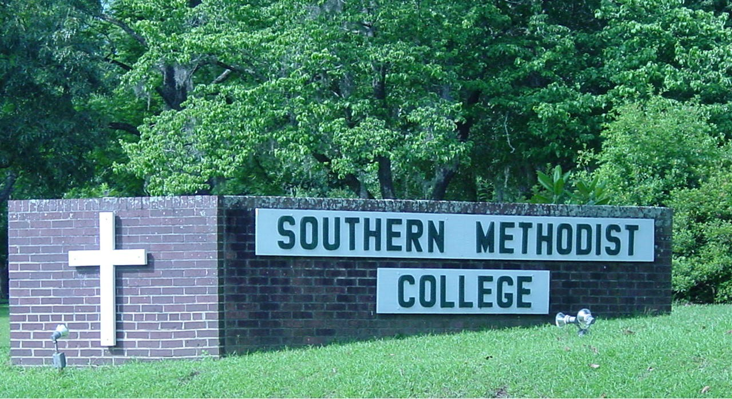

CODE OF CONDUCT
Southern Methodist College is a Christian community devoted to academic study and spiritual nurture. Recognizing our dependence upon God and in acceptance of the absolutes of His Word, we expect that all members of the College family will abide by the following code of conduct.

BIBLICAL ABSOLUTES
The Bible frequently repeats the command, “Be ye holy for I am Holy” (Leviticus 20:7; I Peter 1:15,16). Thus Southern Methodist College believes that there are direct commands and requirements that God has established based upon His own character and that He has revealed these in His inerrant authoritative Word, the Bible. These universal absolutes are non-negotiable, timeless, unchanging and applicable to all cultures. They prescribe Christ-like behavior such as love for God (Deuteronomy 6:5), love for one’s neighbor (Leviticus 19:18), love for the brethren (John 13:34), submitting to God’s Word (Deuteronomy 6:16-17; Matthew 4:4) and to those in authority (Romans 13:1-7), and having self-control (Galatians 5:22-23; Colossians 3:12-17). They also forbid practices such as murder (Exodus 20:13), stealing (Exodus 20:14), dishonesty (Colossians 3:9), taking bribes or kickbacks (Exodus 23:8), profanity (Ephesians 5:4), drunkenness (Galatians 5:21), occult involvement (Deuteronomy 18:9-13), gossip (2 Corinthians 12:20), adultery (Exodus 20:14), sex outside of marriage (Ephesians 5:3), homosexuality (Romans 1:27), rebelliousness (1 Samuel 15:23), and revenge (Leviticus 19:18). All members of the College family must let these absolutes govern their lives at all times and in every place.

PRINCIPLES OF CHRISTIAN LIVING
In Romans 12: 1,2, the Scripture summarizes the standard for Christian lifestyle. “I beseech you therefore, brethren, by the mercies of God, that you present your bodies a living sacrifice, holy, acceptable to God, which is your reasonable service. And do not be conformed to this world, but be transformed by the renewing of your mind, that you may prove what is that good and acceptable and perfect will of God” (NKJV). Southern Methodist College desires that each member of the College family make it a matter of personal commitment to live a life pleasing to the Lord.
The Christian lifestyle is a matter of making day by day choices to live a life pleasing to the Lord. Involvement in or preparation for Christian work requires a personal commitment to "be an example to the believer in word, in conduct, in spirit, in faith, in purity" (I Timothy 4:12, NKJV). Believers should refrain from using tobacco, drinking alcoholic beverages, using illegal drugs, abusing prescription drugs, and from gambling. The College family lives in an imperfect world where many practices, while not forbidden by Biblical absolutes, may be detrimental to spiritual growth and academic endeavor. Therefore, every student and employee must recognize his solemn obligation to uphold his personal Christian testimony and the testimony of the College (I Corinthians 10: 23-24).
The philosophy of Southern Methodist College is based upon the traditional teachings of Methodism, and the College strives to model this philosophy into the lives of students and employees. As a Methodist institution, Southern Methodist College models the three General Rules of Methodist societies which are: do no harm avoiding evil of every kind, do good of every possible sort to all men, and attend upon the ordinances of God (The Southern Methodist Discipline, 2002, paragraphs 117-119). Since Methodism has traditionally regulated all phases of the lives of its followers to the Christian ideal, and since education is preparation for life, the College, holding to these ideals, states reasonable regulations for its students and employees in order to establish an environment that encourages them to conform them to the image of Christ.

AFFIRMATION OF STANDARDS
All board members, employees, and students must give full support in writing to the moral and ethical rules of the institution as stated in the Code of Conduct. Students must give written affirmation on the registration form at the beginning of each semester.

CORRECTIVE ACTION
Southern Methodist College will take corrective action when an individual is found in violation of the moral and ethical standards of the institution. Corrective action involving students may include counsel, suspension, or expulsion.

PLEDGE STATEMENT
I understand that Southern Methodist College is a Christian community devoted to academic study and spiritual nurture and that I am a part of the community. As a member of this Christian community, I represent the Lord Jesus Christ and Southern Methodist College; therefore, I pledge myself to the following commitments:
1. To submit to the authority of the Scriptures in matters of faith and conduct and to the control of the Holy Spirit in my life.
2. To abide by the Code of Conduct both in letter and in spirit. The Code of Conduct is to guide my behavior at all times and in every place.
3. To abide by the policies and procedures within the (Student Handbook, Faculty Handbook, Staff Handbook, Board Handbook). While I may not appreciate or understand every policy or regulation of Southern Methodist College, I will honorably adhere to them and respectfully cooperate with those who are in authority.
4. To strive for excellence in all that I do.
5. To refrain from behavior that may cause another person to sin or stumble.
I understand that failure to cooperate in maintaining the Code of Conduct or this pledge will lead to counsel, appropriate disciplinary action, and possible dismissal.

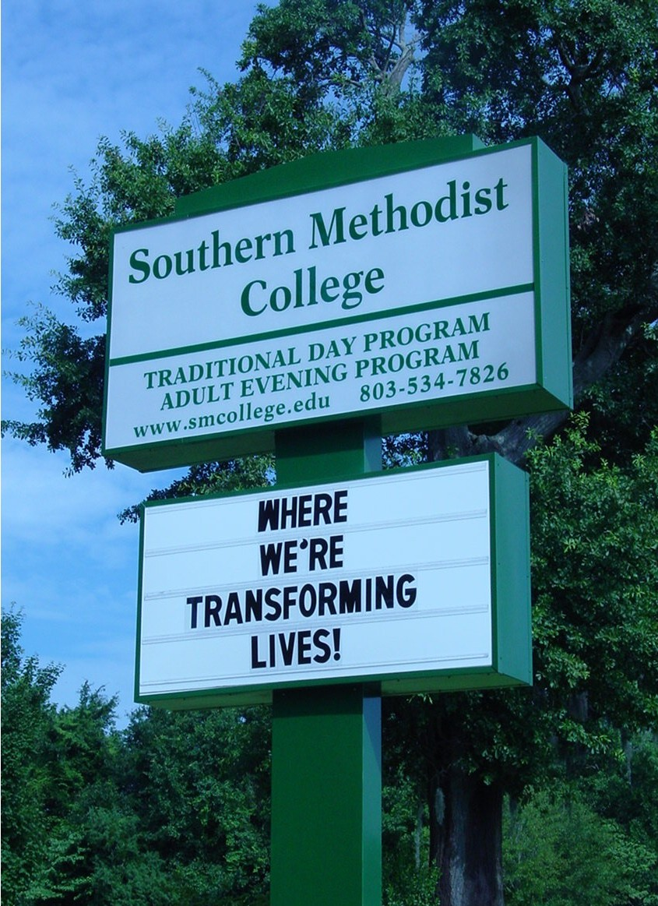

PERSONAL COMMITMENTS

GENERAL REGULATIONS
Southern Methodist College requires students to abide by the rules, policies, and standards of conduct as stated in this catalog and in the Student Handbook. Students accepted for admission must read, understand, and respect the Doctrinal statement and affirm in writing their agreement to abide by the code of conduct of the College.

SPIRITUAL LIFE
Student life focuses on opportunities for both spiritual growth and ministry. Each student is required to attend Sunday services at a Bible-believing church.
Since Christian service is part of the Christian life, the College encourages various service opportunities including evangelism, Christian education classes, and ministry in churches and parachurch organizations.

STUDENT HONORS AND AWARDS
Recognition for achievement is wholesome; therefore, the College periodically recognizes accomplishments in various areas by honors and awards such as academics, school spirit, continuing education, and others as deemed appropriate by the Administration.

STUDENT CONDUCT
Southern Methodist College, as a Christian institution, is committed to spiritual growth and the development of Christian standards in the life of each student, for Scripture teaches, "...be an example to the believers, in word, in conduct, in love, in spirit, in faith, in purity" (1 Timothy 4:12, NKJV). The College desires that each student make a personal commitment to live a life pleasing to the Lord.
The philosophy of Southern Methodist College is based upon the traditional teachings of Methodism, and the College strives to incorporate this philosophy into the lives of the students. Since Methodism has traditionally regulated all phases of the lives of its followers to the Christian ideal, and since education is preparation for life, the College, holding true to these ideals, states reasonable regulations for its students in various phases of student life in order to establish an environment which encourages conformity to the image of Christ.

ADMISSIONS INFORMATION

GENERAL REQUIREMENTS
Admission to Southern Methodist College is a privilege granted to selected students. Applicants for admission to the College must give satisfactory evidence of good Christian character, present credentials indicating ability to profit from the curriculum, and agree to conform to the Code of Conduct of the institution. Students accepted for admission must affirm in writing at the time of registration that they have read, do understand, and will respect the Biblical Foundations doctrinal statement.
Southern Methodist College does not discriminate on the basis of gender, age, race, disability or handicap, veteran status, nationality, or ethnic origin in administration of its educational policies, admissions policies, scholarships, employment, or other school-administered programs. This position is a Biblical conviction based on Galatians 3:28: "There is neither Jew nor Greek, there is neither slave nor free, there is neither male nor female; for you are all one in Christ Jesus" (NKJV).
Ability to succeed academically will be determined by any or all of the following:
- A High School diploma or G.E.D;
- A high school transcript with a 2.0 GPA or higher, or for transfer students with a minimum of 12 semester-hours of prior college credit, a college or post-secondary transcript with a 2.0 GPA or higher;
- An ACT score of 18 or higher or SAT score of 850 or higher. The test score requirement will be waived for transfer students who have completed a minimum of twelve semester hours of college work with a minimum GPA of 2.0. International student applicants may submit a TOEFL paper score of 525 or higher or computer-based score of 195 or higher in lieu of the ACT or SAT requirement., or meet an alternative standard approved by the Administration.
The Director of Admissions will have authority to admit applicants who meet the ability to succeed standard. Applicants not meeting the criteria will be referred to the Admissions Committee of the Administrative Cabinet for consideration. Applicants not meeting the ability to succeed standard may be recommended by the Admissions Committee for consideration for admission on academic probation.

* ADMISSIONS PROCEDURE
Any student desiring to attend Southern Methodist College should
- Secure the packet of application forms and materials, fill in the application form completely, and return it with the $35 non-refundable application fee to the Director of Admissions, Southern Methodist College, 541 Broughton St., Orangeburg, South Carolina 29115. Forms are available on campus, upon request through the traditional mail system, and on-line at www.smcollege.edu or at www.online.smcollege.edu. There is also an on-line payment option.
- Request that an official transcript of the student's high school record, any previous college records, and records of non-credit or institute study be mailed directly from the educational institutions to the Director of Admissions of Southern Methodist College.
- Ask references to return completed reference forms directly to the Director of Admissions.
The entire admission procedure should be completed at least thirty days prior to the date of registration.

PLACEMENT AND ENTRANCE EXAMINATIONS
Degree candidates may qualify for College credit and advanced placement through the College Level Examination Program (CLEP), advanced placement examinations, or college level subject examinations by requesting this option from the Academic Dean.

CATEGORIES OF ADMISSION
All students taking courses for college credit must complete the formal application process.

Freshman Standing
Freshman standing is granted to applicants who have met admissions requirements. Applicants must present satisfactory admission credentials on the basis of a High School Diploma, or a General Education Development (GED) High School Certificate.

Advanced Standing
Transfer students seek admission to the College in the same manner as first-time freshmen and are responsible for requesting high school and college transcripts to be sent directly to the Admissions Office at the time of applying for admission. No applications can be processed until all records are received.
After completing all admission procedures and requirements, applicants for admission with advanced standing will be given a statement of credits to be accepted in transfer by the College.

SPECIAL CATEGORIES OF ADMISSION

Non-degree Special Standing
Non-degree special standing may be given to students who wish to take courses without working for a degree.

Audits
An "audit" student may sign up for specific courses at the discretion of the Academic Dean and faculty. No formal application process is required. The student will complete a semester registration form for each semester he or she wishes to audit courses. No college credit is given for work completed when the course is audited.

Veterans
Southern Methodist College is approved by the South Carolina Department of Education State Approval Agency, for veterans who are eligible to receive benefits under the Veteran's Educational Assistance Act, Disabled Veterans Act, or War Orphans Acts.
V.A. benefits will be terminated for failure to adhere to the institutional standards of academic progress.

Ability-to-Benefit Students
Ability–to-benefit students do not meet the academic admissions standard of a high school diploma or GED but show potential for freshman-level work as determined by the Admissions Committee and the Administration. Recognizing that a student’s academic record may not accurately reflect his spiritual, psychological, and intellectual maturity, the College accepts a limited number of ability-to-benefit students.
The Administration will consider requests for acceptance with ability-to-benefit status and designate a student as ability-to-benefit as part of a special application review process. Students not accepted as full-time students may apply for non-degree standing.

Early Admissions (Dual Credit Policy)
High school students expecting dual credit must have permission from the appropriate high school authority and must enroll under the following criteria:
Must enroll for college credit
Must meet all course requirements (stated in the course syllabus) for college credit
Must be a rising Junior or Senior in high school
Must have a 3.0 high school GPA
The Scholarship Committee will make available a limited number of scholarships to dual credit students on a need basis.

International Students

Southern Methodist College enrolls international students in its on-line program. The College does NOT offer resident studies or an I-20 contract to interested international students. A limited number of international student scholarships are available and are awarded on the basis of merit and need.
Procedure for application for admission:
- Contact Southern Methodist College, 541 Broughton St., Orangeburg SC 29115, for an application and other application materials. Return the application with a $50 non-refundable application fee. Application materials are also available on-line at www.smcollege.edu or at www.online.smcollege.edu.
- Make arrangements to take the Test of English as a Foreign Language (TOEFL) and have the results sent directly to the College. The American Consulate can make available the TOEFL. A satisfactory score is required for admission. The applicant may request for and meet an alternative standard approved by the Administration.
- Have academic records sent to the College directly from the issuing institutions, accompanied by a certified translation if not written in English. The transcripts of all post-secondary study should be sent along with a catalog, syllabus, or written description of each course taken, accompanied by a certified translation if not in English.
- Have references return completed reference forms directly to Southern Methodist College.
If for any reason the international student applicant is unable to enroll at Southern Methodist College, the applicant may request that funds other than the application fee be refunded or that funds be held by Southern Methodist College until such time as the applicant is able to enroll.

Readmission of Students
Students seeking readmission to the College should submit a written request for readmission to the Director of Admissions. The Director of Admissions will readmit the student when he has been cleared for readmission by the Administration.
A student who is denied re-enrollment for academic reasons may apply for readmission after a period of one semester. A student who is expelled or denied re-enrollment for disciplinary reasons may apply for readmission at the discretion of the Administration after a period of two semesters. A student who is denied readmission for financial reasons may apply for readmission after the student account is made current.

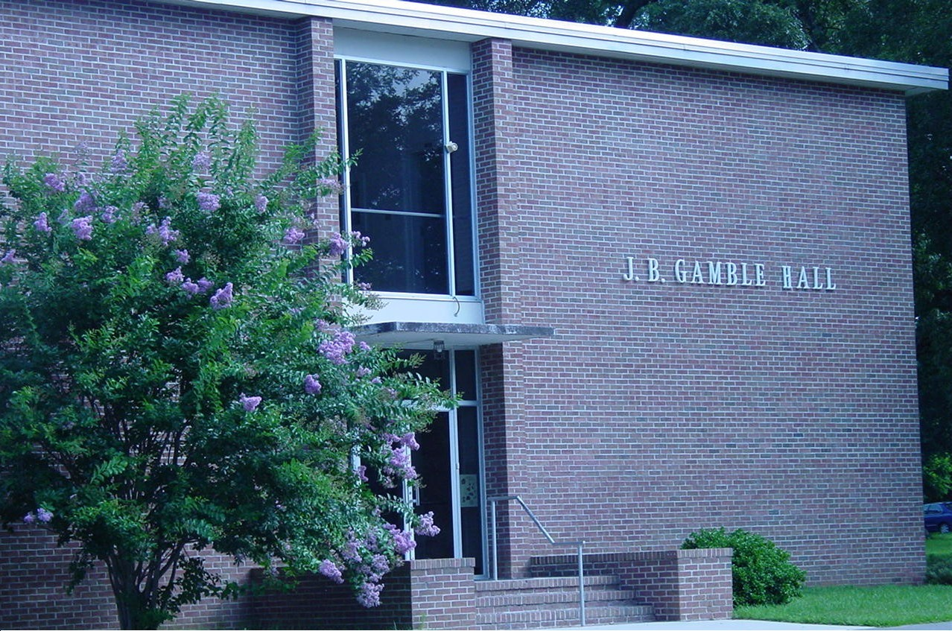

FINANCIAL INFORMATION
Southern Methodist College desires that the opportunity of a Christian education be given to worthy, motivated men and women. By keeping expenses at a minimum, the College provides an educational opportunity for many students who otherwise may not be financially able to attend college. The testimony of Southern Methodist College depends upon the power and grace of our Lord Jesus Christ, and on all those who are committed to the College, both financially and spiritually.
Students will not be allowed to begin attending classes at the beginning of the new semester until their accounts are satisfied with the Business Office; nor will students with unpaid accounts be allowed to receive a degree or a certificate or to receive a transcript.
Special payment arrangements, if needed, must be made through and approved by the Administration.
All fees are subject to change. This fee schedule is effective August 1, 2022 for the 2022-2023 academic year.

STUDENT FEES

Tuition per undergraduate course $500
Tuition per graduate course $600
Tuition per continuing education course $100
Registration fee per course (non-refundable) $25

SPECIAL FEES
Application fee (non-refundable) $35
International student application fee (non-refundable) $50
Graduation fee $50
Transcript fee (after the first copy) $10
Proficiency credit (CDC) per three hours course $100
Validation examination fee per examination $25

The cost for auditing a class is one half of regular course tuition ($250, undergraduate; $300, graduate), plus the registration fee. Senior Citizens 60 years or older may enroll in an undergraduate course for credit or audit for a charge of $250 per course plus the registration fee. Senior Citizen discounts may be paid through scholarship funds at the discretion of the Scholarship Committee.
After a term begins, students are allowed one week to make any necessary adjustments to their schedules without charge. Any course dropped after the third week will receive a grade of “WF” or “W” according to the ruling of the Administration. The student must notify the Academic Dean in writing when dropping a course to avoid academic penalty.
The graduation fee includes the cost of the diploma, the first copy of a student transcript, and commencement related expenses, and is payable in full whether the candidate receives the degree in person or in absentia.

METHODS OF PAYMENT
The responsibility for payment of accounts rests with the student. The College will lend all possible aid but does not accept the responsibility for the payment of student accounts.
The Business Office prefers that student charges for the new semester be paid in full at the beginning of each semester; however, alternate payment plans (for example, 25% of a student's balance paid monthly) are available for students who need financial assistance. The Administration must approve any proposed payment plan at the beginning of the semester.
Any student whose account is not paid in full at the end of the semester will not be allowed to re-enroll for the next semester. Unpaid student accounts will be submitted to a collection agency after one semester; collection fees and legal fees will be added as necessary.

REFUNDS
If a student cancels enrollment before classes begin at the beginning of a semester, all tuition payments will be refunded. If a student cancels enrollment within seven days after classes begin, the refund will be 100% of tuition paid.
When a day student officially withdraws from the institution after seven days, refunds on semester charges for tuition will be prorated based on the amount of the term that has transpired up to 60% of the term. There will be no refund after 60% of the term has passed. No refund will be granted if a student leaves a class(es) without officially withdrawing.

Transcripts
The College will issue one transcript free of charge for each student and will charge ten dollars for each additional transcript. No transcript will be released if the student's account is not paid in full. Transcripts are available through the Records Office. You may also fill out a transcript request form online at www.smcollege.edu or at www.online.smcollege.edu.
SATISFACTORY ACADEMIC PROGRESS POLICY
Students receiving financial aid must maintain satisfactory progress as defined by the College. The student must maintain a grade point average at or above 2.0. Any student whose cumulative GPA falls below 2.0 will be placed on academic probation. Students will not be affected by “incompletes” at the time of the review.
With the exception of students placed on academic probation, satisfactory progress will be monitored at the end of each academic semester. Students who have not successfully attained the minimum GPA at the conclusion of their probationary period may have their financial aid terminated.
The Business Office will send a warning letter to any student who is placed on academic probation or a termination letter to any student who is no longer eligible for financial aid. Students who have been disqualified from receiving financial aid may petition the Administration to waive the satisfactory progress requirements only where there are special circumstances present. A student may submit written documentation to the Administration that explains unavoidable circumstances that have affected academic performance.

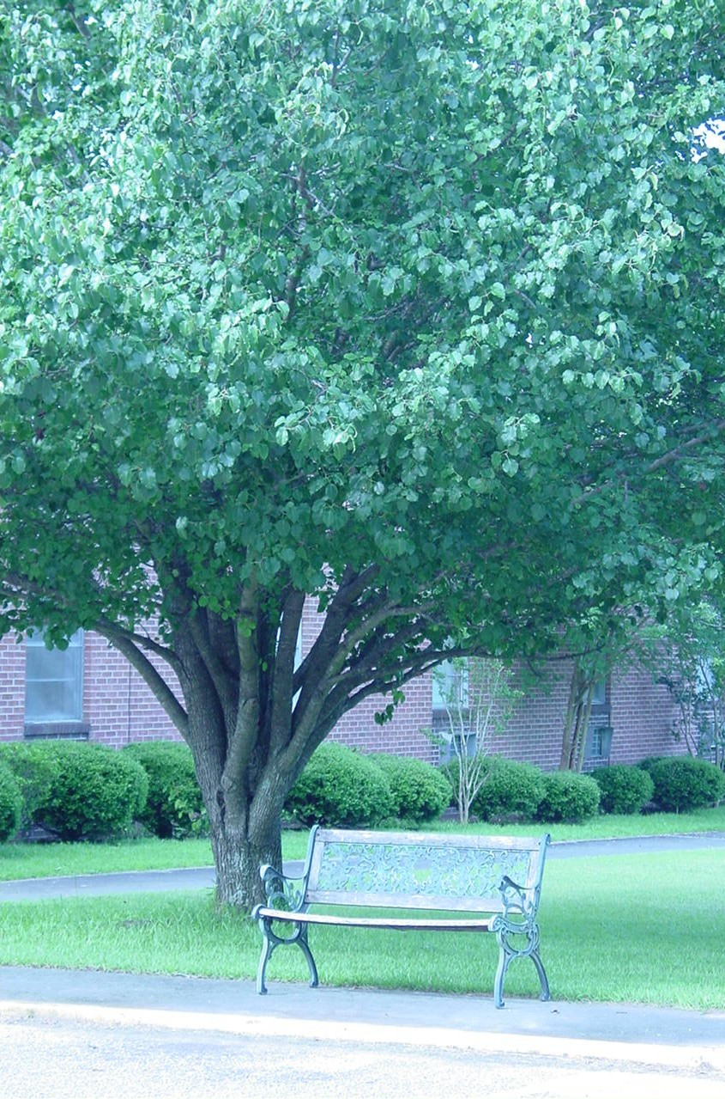
A Place for Meditation

FINANCIAL AID
The following resources available to students applying for grants and scholarships.

ELIGIBILITY
Every student enrolled at the College is eligible to apply for financial aid; however, none will be considered until the student has applied for admission. Aid is granted on the basis of financial need, scholastic ability, and promise of future growth and service. Non-degree students must complete registration before any financial aid is awarded.
Students must be accepted for admission to the College before any action can be taken on their application for financial assistance, including scholarships, or other financial aid programs.

AVAILABILITY
Financial aid is available as grants and scholarships.. Students are eligible to apply for private scholarship programs.
In-house scholarships are awarded each semester and are renewable for the following academic year by reapplication. The College reserves the right to withdraw a scholarship at any time if the student fails to meet the conditions of the scholarship or to maintain the acceptable scholastic standing or to be in accord with the standards of Southern Methodist College.

ADOPT-A-STUDENT
The Adopt-A-Student program is designed to involve a local church, a group of concerned friends, or an individual with a commitment to seek out a student attending Southern Methodist College and to support that student financially with a regular monthly contribution.

CONFERENCE SCHOLARSHIPS
The four Southern Methodist Annual Conferences provide scholarships for students from their conferences to attend the College. Applications for these funds must be made to the applicant's conference prior to the annual meeting in July.

MISSIONARY SOCIETY SCHOLARSHIPS
Scholarships are provided for Southern Methodist students from their respective conferences by the Woman's Missionary Societies. Application for these funds should be made to the WMS of the applicable Southern Methodist annual conference. Scholarships are also provided for Southern Methodist students by the General Conference Woman's Missionary Society. Application for these funds should be made to the General Conference WMS.
The Birdie Adams Scholarship of the Southern Methodist General Conference Woman's Missionary Society
Alabama-Florida-Georgia Woman’s Missionary Society
Eastern Conference Woman's Missionary Society: the Marian Gamble Scholarship, named for the late Mrs. Marian Gamble, mother of the Rev. Julian B. Gamble, is available to students preparing for service as missionaries.
Mid-South Woman's Missionary Society
Southwestern Conference Woman’s Missionary Society

CARTWRIGHT MEN’S FELLOWSHIP SCHOLARSHIPS
These scholarships are awarded upon recommendation of the Fellowship and/or the Scholarship Committee:
The Middle Tennessee Southern Methodist Fellowship Scholarship
Orangeburg Cartwright Men's Fellowship Scholarship

GRANTS & SCHOLARSHIPS
The Scholarship Committee of the College awards the following grants and scholarships to eligible students who are enrolled at the College. Awards are given subject to the availability of funds and are valid only as long as the student remains in good standing as a student at Southern Methodist College.

Jeff and Myrtle Taylor Barton Scholarship. This scholarship is named for Mr. and Mrs. Barton who were members of the Hephzibah Southern Methodist Church of Hephzibah, Georgia, as an endowed scholarship for ministerial training.
Rev. C.K. Brooks Scholarship. This scholarship is given to a needy, qualified student preparing for Christian service. Preference will be given to students from the Southwestern Annual Conference of the Southern Methodist Church. The recipient must maintain a 2.5 G.P.A.
The Chatlos Foundation Scholarship. This general scholarship was established for needy and deserving students.
Mary and Floyd Clagett Scholarship. Mary and Floyd Clagett from Centerville, Tennessee established this endowed scholarship for students of the College.
The Reverend William Gwynn Coe, D.D., Memorial Scholarship. This scholarship was established by Mr. Raymond G. Coe of Washington, D.C. in memory of his grandfather for ministerial students in the Southern Methodist Church. The recipient must give one year of service in the Southern Methodist Church for each year that the scholarship is awarded to him.
Ethel Lide Council Scholarship. This endowed scholarship is for needy, worthy applicants who are residents of the state of South Carolina.
Boyd E. Devall Memorial Scholarship. Mrs. Jewell M. Devall has established a scholarship fund with annual awards in loving memory of her husband Boyd E. Devall. Preference will be given to students from Texas, Louisiana, and Arkansas, though all students are eligible.
Kathryn Fink Dunaway Scholarship. This endowed scholarship was established by the Alabama-Florida-Georgia Annual Conference. Preference is given to students from that conference.
Scholarship Endowment by First Southern Methodist Church, Gadsden, Alabama. Funds from this endowment are available to all students based upon need with preference given to ministerial students intending to serve in the Southern Methodist ministry.
The Forrest, Patricia, and Birdie Green Scholarship - This scholarship was established by the Forrest and Patricia Green family in memory of their father, Forrest; their mother, Patricia; and their sister, Bertie Green.
Larry Haigler Scholarship. This is a general scholarship with preference given to students who participate in the Work Study Program.
The Hartzog Memorial Scholarship - This scholarship was established in memory of Jack and Adrienne Hartzog of Hilda, South Carolina, and provides scholarships to needy and deserving students.
The Lockeridge Scholarship. This is a general scholarship award based upon the need of the student.
Lovell Endowment Scholarship. This scholarship, established by Mr. and Mrs. Charles Lovell of Nashville, Tennessee, provides funds for students preparing for service as a minister, a missionary or a full-time Christian education worker. The recipient must give one year of service for each year that the scholarship is awarded; two years, if a non-graduate.
The Nolen Scholarship - This scholarship provides scholarships to needy and deserving students.
The Evelyn Patrick Scholarship. This scholarship was established by Mr. Bryan Patrick in memory of his wife Evelyn Patrick.
Marion Robert Rowe Memorial Scholarship. Mrs. J. R. Rowe of Augusta, Georgia established this endowed scholarship, in memory of her son.
Stabler-McGowan Scholarship. This scholarship was established by Mrs. M. B. McGowan of Columbia, South Carolina, in memory of her husband and parents, and provides funds for students preparing for service as a minister, a missionary or a full-time Christian education worker.
SPIN (Special People in Need) Scholarship. This general scholarship was established for needy and deserving students.
The Volpe Scholarship - This scholarship provides scholarships to needy and deserving students.
G. W. Weathers, Sr., Scholarship. This scholarship fund is an endowment established by the late Mr. and Mrs. G. W. Weathers, Sr., of Bowman, South Carolina, to provide scholarships for students who intend to enter full-time Christian work as a minister, a missionary or a Christian educator in the Southern Methodist Church.
Virginia B. Wright Memorial Scholarship. This endowed scholarship was established by Dr. Charles E. Wright, Goodlettsville, Tennessee, in memory of his wife.
Adopt-a-Student Program. The President, in consultation with the Scholarship Committee, may enroll students in the Adopt-a-Student Program and match each approved student with an appropriate donor (individual, church, or organization) volunteering to make regular tuition donations to the College in the name of the student.
Presidential Grant. The President, in consultation with the Scholarship Committee, may make scholarship grant awards to students with special needs.

Adden Hall

ACADEMIC INFORMATION

THE ACADEMIC PROGRAM
Southern Methodist College offers a program of studies leading to four different programs, all focusing on Bible and Christian Ministries. The program is offered primarily on-line with a limited number of classes offered on-site.
The College offers a one-year certificate program in Biblical Studies.
The College offers a two-year Associate of Arts degree in General and Religious Education.
The College offers a four-year degree in Bible with a Christian Ministries double major.
The College offers a one-year Master of Biblical Studies program for students having completed a Bachelor of Arts degree.
All students must demonstrate the ability to earn a degree by at least one full semester of satisfactory work before being considered a candidate for a degree.
Southern Methodist College confers only earned degrees, not honorary degrees.

COURSE OFFERINGS
The schedule of classes for each semester is established to meet the curricular need of the degree student. The College assumes no responsibility to offer courses for transient or non-degree students. The College reserves the right to make changes in course offerings when deemed advisable by the Administration.

THE ACADEMIC YEAR
The academic year is divided into two semesters beginning in August (fall semester) and in January (spring semester). Each semester is divided into two eight-week terms. A summer semester is also scheduled each year. A flex schedule program is also available upon request and approval of the Administration.

REGISTRATION
Pre-registration is held at a time announced on the college calendar. Registration is finalized at the beginning of each semester term. Each student is assigned to a faculty advisor for assistance in the registration procedures; however, the responsibility for taking the courses required for fulfillment of any degree or certificate program rests with the student.

CREDIT HOURS
The semester-hour is the unit of credit for all courses. Thirty semester hours are required for the Certificate in Biblical Studies. Sixty semester hours are required for the Associate of Arts degree. One hundred twenty semester hours are required for the Bachelor of Arts degree. Thirty additional semester hours (in addition to a Bachelor of Arts degree in Bible or Religious Studies) are required for the Master of Biblical Studies degree.

ACADEMIC LOAD
A full-time student may register for an academic load of up to eighteen hours. A student with at least a 3.0 grade point average may register for three additional hours once during his program of study with permission of the Administration. A full-time student must register for no fewer than twelve semester-hours. A student who registers for fewer than twelve semester-hours is considered to be a part-time student, but may take courses leading to a degree. A non-degree student is one who registers for courses but who is not a candidate for a degree.

ACADEMIC CLASSIFICATION OF STUDENTS
Academic classification is based on the total number of semester hours earned. A student with fewer than 30 semester hours is classified as a freshman. A student who has earned 30 semester-hours with all entrance deficiencies removed is classified as a sophomore, 60 semester-hours, as a junior, and 90 semester-hours, as a senior.

GRADES, QUALITY POINTS, AND GRADE POINT AVERAGE
All work is graded by letters that are assigned grade points per semester hour as follows:
Grade Grade Points Definition Numerical Score
A 4.0 Excellent 90-100
B 3.0 Good 80-89
C 2.0 Satisfactory 70-79
D 1.0 Passing 60-69
F 0 Failure 0 -59
S Satisfactory (non-credit courses only)
U Unsatisfactory (non-credit courses only)
I 0 Incomplete
W 0 Withdrawn from course
WF 0 Withdrawn from course, failing
AU 0 Audit
Quality Points are the number of Grade Points received for a course multiplied by the semester-hours attempted. Courses with a grade of “S,” “U,” or “W,” reflect 0 hours attempted; the number of semester-hours attempted is equivalent to the load for a course with any other grade. Grade Point Average is computed by dividing the total number of Quality Points earned by the total number of semester-hours attempted.

Grade Reports
Students will receive periodic evaluation each semester from the instructor. Students will receive a course grade report at the conclusion of each course. All students will receive an academic check sheet with final semester grades following the end of each term.

Honor Rolls
Full-time students earning a semester grade point average of 3.7 with no grade less than a “B” are named to the President's List at the conclusion of the semester. Full-time students earning a semester grade point average of 3.0 with no grade less than a “C” are named to the Dean's List.

Incomplete
A grade of “Incomplete” is given by an instructor only if the student, prior to the end of the course, has requested additional time to complete course assignments due to illness or extenuating circumstances, and the instructor concurs that the request is justified. Students who receive an "I" for incomplete course work are required to complete the work by a date set by the instructor and no later than middle of the following term unless special approval has been granted by the Administration.
If a student fails to meet the deadline given for resolving the grade of "Incomplete," the instructor will submit a grade based on work received before the deadline, which will include a grade of zero for any required work not submitted.

CHANGE OF COURSE
After the end of registration, students are allowed one week to make any necessary adjustments to their schedules without cost.
Courses dropped during the first week following the end of registration will be removed from the student’s record. Classes dropped after the first week but prior to the end of the third week of the term will be posted with a grade of “W.”
Any course dropped after the third week will receive a grade of "WF" unless the Administration rules that a "W" is justified due to extenuating circumstances. The student must make a request in writing for consideration of extenuating circumstances.
The student must follow these procedures for dropping a course to avoid academic penalty:
1. Make a request in writing to the Administration.
2. Have the change approved by a faculty advisor.
3. If adding a course which brings the student over the applicable load limit, secure approval from the Administration.
The Registrar will send the student confirmation of the change.

CLASS ATTENDANCE
Regular and punctual attendance in all classes is expected whether on-line or on-site and academic deadlines met. On-line classes and class requirements are available through a dedicated website maintained by the Director of Internet Services. There will be an automatic 10% deduction for late work unless excused by the Instructor or Academic Committee.
Students are expected to be on time for on-site classes. A student may not miss more than one scheduled classes for an on-site course. Absence from more than one scheduled class will result in bring dropped from the class with a grade of WF. A student may appeal to the Administration for a W if there are extenuating circumstances.

TRANSCRIPTS
Official transcripts will be issued to another institution upon written request from the student. Students may request an unofficial transcript of their academic record. After the first transcript, a fee of $10 is charged for each additional transcript. No transcript will be released if the student’s account is not paid in full.

GRADUATION REQUIREMENTS
The College Board of Directors approves all candidates for degrees and certificates at the regular fall and spring meetings pending satisfactory completion of academic requirements for graduation and barring serious moral failure that results in expulsion by the Disciplinary Committee.
The Certificate in Biblical Studies is offered to all students who satisfactorily complete requirements for this program as outlined in the Catalog.
The Associate of Arts degree in General and Religious Education is offered to all students who satisfactorily complete requirements for the degree as outlined in the Catalog.
The Bachelor of Arts degree in Bible is offered to all students who satisfactorily complete requirements for the degree as outlined in the Catalog.
The Master of Biblical Studies degree is offered to all students who satisfactorily complete requirements for the degree as outlined in the Catalog.
In addition, a degree candidate must
1. Complete a minimum of 120 credit hours for the Bachelor of Arts in Bible degree or 60 credit hours for the Associate of Arts degree; complete 30 hours in addition to a Bachelor's degree for a Master of Biblical Studies degree.
2. Earn at least a 2.0 Grade Point Average at Southern Methodist College.
3. Receive at least a “C” in each of the following courses: all required courses in Bible, and the courses En 101 English Composition I and En 102 English Composition II.
4. Complete the final 30 semester hours at Southern Methodist College (24 semester hours for the Certificate in Biblical Studies and the Master of Biblical Studies).
5. Settle all financial obligations to the College before a degree (or certificate) may be granted or a transcript released.
A student may request to participate in the annual commencement service with academic concession (six semester hours or less) or with financial obligations to the college. The decision of the administration on any such request is final. A diploma will not be released to the student until all academic and financial obligations are met.

GRADUATION WITH HONORS
A candidate for the Bachelor of Arts in Bible degree will be graduated with honors as follows:
cum laude 3.30-3.60 GPA
magna cum laude 3.61-3.80 GPA
summa cum laude 3.81-4.00 GPA
The grade point average is based on the student's entire college program. In computing the average, work taken elsewhere which has been accepted in transfer is considered at the same grade value as in the school where it was earned.

TRANSFER CREDIT
The College reserves the right to determine what credits, if any, for courses taken elsewhere shall be counted toward a degree, and will give consideration to and acceptance of transfer credit according to the following policies and procedures. The Administration will consider the quality of the course content, timeliness of the work, and student performance (a minimum grade requirement) in evaluating transcripts from another institution. The assignment of credits is made on the basis of the content of the course pursued elsewhere as compared with parallel courses offered by the College. The accredited status of the institution is a significant factor in the evaluation, but not the sole determinant of the transfer decision.
No grade below "C" is accepted for transfer credit. Quarter hours earned elsewhere are evaluated at the ratio of three quarter hours to two semester hours. No fractional credits are transferred.
Credits earned in a Bible school that does not have a recognized college department (not classified as a college) may be transferred only by validation determined by examination.
Credits earned in an alternative educational setting will be evaluated for demonstrated competencies according to guidelines recommended by recognized accrediting associations (CAEL, ACE).
Students submitting work from non-accredited colleges or alternative educational settings will be responsible to assist the Academic Dean in the evaluation by providing the following upon request: course syllabi, faculty credentials, and course materials.
A statement of transfer credit is provided to the student during the admissions process. The student will be informed in writing of any reasons for refusing to accept transfer credits.

BIBLE REQUIREMENT
Every full-time student must register for a Bible course each semester unless granted exemption by the Administration.

RESIDENCE
In order to earn a B.A. degree at Southern Methodist College, a student must complete a minimum of eighteen semester-hours in the major field (Bible) and eighteen semester-hours in the double major field (Christian Ministries) at Southern Methodist College, and must complete the final thirty semester-hours of the program at the College unless approval is granted by the Administration. Work completed at the College may be on-line or on-site. The term residence refers to either online or onsite venues.
Any student leaving the College before completing requirements for graduation must meet the requirements specified in the catalog current at the time of re-enrollment.

NON-RESIDENCE WORK
A limited amount of work from other college institutions may be taken while in residence at Southern Methodist College and transferred to count toward the requirements for graduation. A maximum of 30 semester-hours may be obtained in this manner. Any such work taken during the time that the student is in residence must be counted as part of the student's load for the semester and approved in advance by the Administration.

VALIDATION EXAMINATIONS
Students desiring academic credit for course content for which credit was not earned at an accredited or recognized institution may seek validation by examination after enrollment at the College. A fee of $25 is charged for each validation examination. This procedure also applies to academic work taken in Bible schools that do not have an approved college department.

ACADEMIC PROBATION
The Academic Committee will place new students on academic probation for any of the following reasons:
1. The lack of a high school diploma or a General Equivalency Diploma in the case of a student who shows academic ability or potential (for example, an early admissions student or an ability-to-benefit student).
2. The high school transcript indicated questionable academic ability.
Students placed on academic probation upon enrollment for any of the three reasons stated above will remain on probation until the student demonstrates the ability to do college level work (a 2.0 Grade Point Average or higher). Probationary students unable to do college level work may be allowed to enroll for additional semesters at the discretion of the Administration but for a total of no more than three semesters total before being denied re-enrollment.
The Administration reviews the records of all students, including students on academic probation and the students whose grades are unsatisfactory, each semester. Students whose Grade Point Average falls below 2.0 after enrollment will be placed on academic probation. If a student's record shows satisfactory improvement (at least a cumulative GPA of 2.0), the student will be removed from academic probation. If satisfactory improvement is not shown in the student’s GPA after two semesters on academic probation the student will not be permitted to re-enroll for one semester, after which the student may request consideration of the Administration for re-enrollment.
Students not earning a 1.0 GPA in the first semester may be denied reenrollment at the discretion of the Administration.
Students may be denied re-enrollment by the Administration at any time for habitual non-compliance with academic requirements of the curriculum.
The Registrar periodically reviews the academic regulations of the College and recommends to the Faculty and Administration any revisions deemed necessary. The Administration considers special requests or situations that represent any deviation from established policies and renders an official decision in each case.

DISCIPLINARY PROBATION, SUSPENSION, EXPULSION
Students will be placed on disciplinary probation, suspended, expelled, or denied re-enrollment by the Administration for serious moral failure or habitual non-compliance to the Biblical standards of the institution.
Students who are expelled or denied re-enrollment may apply for readmission after a period of two semesters by stating in writing the reasons for requesting readmission and by scheduling a personal interview with the Administration.

OFFICIAL WITHDRAWAL FROM THE COLLEGE
Students who withdraw must submit a written withdrawal request to the Registrar or Administration in order to avoid a grade of “WF” in all registered classes.
Students will receive a grade of "W" for all semester courses if they withdraw before the three week deadline and a grade of "WF" if they withdraw after the three week deadline. Students who withdraw after the three week deadline must submit a written request to the Administration explaining any extenuating circumstances in order to avoid receiving a grade of "WF" for all courses.
The decision of the Administration shall be final.

UNOFFICIAL WITHDRAWAL
Students who cease to meet the published class schedule without completing the official process for withdrawal remain on active status until such time as the academic term ends, at which time they are declared officially withdrawn, with a grade of “WF” in each course.

TRANSFERRING CREDIT
Completion of courses and/or a certificate program and/or a degree program at Southern Methodist College does not guarantee that credit earned will transfer to another institution nor does the College guarantee employment after graduation. However, the administration and staff will make every effort to assist students in transferring credit to another institution and in securing a position of employment.
Admissions personnel will provide practical information and guidance to prospective students concerning the likelihood of transferring credits to another institution. Academic personnel will provide print or electronic assistance for students considering transfer to another institution.

Gamble Hall

ACADEMIC PROGRAMS

GENERAL EDUCATION REQUIREMENT
All degree programs have a foundation of general education requirements meeting minimum accreditation standards because the liberal arts are essential to the development of a Biblical worldview and an intelligent interaction within a secular society. Graduates will show evidence of academic skill and educational proficiency comparable to students in post-secondary institutions nationally. They will demonstrate critical thinking, decision-making, and creative oral and written expression.
The curriculum fulfills the stated purposes and objectives of the institution.

DEGREES OFFERED

Master of Biblical Studies

Bachelor of Arts in Bible - Christian Ministries double major

Associate of Arts in General & Religious Education

CERTIFICATES OFFERED

Certificate in Biblical Studies

BACHELOR OF ARTS IN BIBLE (120 Hours)

Bible Major Objectives
The Bachelor of Arts degree in Bible provides the student a general education core requirement, a 36-hour Bible major, and a vocation related double major program in Christian Ministries in fulfillment of the general purpose and objectives of Southern Methodist College.
The graduate of this program will be able to:
- Interpret Scripture using the historical-grammatical method.
- Exhibit a foundational knowledge of the integrated content of the Bible.
- Describe accurately fundamental Christian doctrine and articulate a personal theology.
- Demonstrate a Biblical philosophy of life reflected in personal ethics and personal characteristics necessary for effective ministry.
- Communicate persuasively the Biblical message and minister effectively in Christian and non-Christian settings.
- Research and compose scholarly papers.

Christian Ministries Double Major Objectives
The Christian Ministries double major program prepares the student for competent leadership and effective ministry in a chosen field of Christian service or church related profession. The flexibility of this program allows a student choices in elective courses related to a specific area of interest or ministry. A student may select courses in the areas of pastoral studies, missions, youth work, Christian school education, or leadership and ethics.
In addition to the abilities gained through completion of the Bible major, the graduate will be able to demonstrate the following:
- Integration of ministry theory into personal life and practical service.
- Personal characteristics necessary for effective ministry, including the ability to work with and minister to all people.
- Discovery and development of spiritual gifts.
- Evangelization of the lost and discipleship of new Christians.
- Leadership in effecting a philosophy and strategy of ministry that results in Christlikeness.
- Evaluation of the spiritual needs of a group and the development of a ministry program to meet those needs.

Program Overview
The Bachelor of Arts in Bible degree will consist of four components as follows:
Liberal Arts – 36 semester hours minimum
Bible major – 36 semester hours
Double major – 36 semester hours minimum.
Unrestricted electives – 12 semester hours estimated.
The total number of semester hours required for completion of a Bachelor of Arts degree program is 120.

General Education Requirement (36 semester hours)
The Liberal Arts (general education) component for every B.A. student (day and evening) will be the same:
English - 15 semester hours
- English Composition & Grammar – 6 hrs.
- Literature – 6 hrs.
- Speech – 3 hrs.
History / Social Science - 15 semester hours
- History of Civilization – 6 hrs.
- History elective – 3 hrs.
- General Psychology – 3 hrs.
- Ethics - 3 hrs.
Mathematics / Elective - 6 semester hours
- College Mathematics – 3 hrs.
- Liberal arts elective – 3 hrs.

The Bible Major Requirement (36 semester hours)
The Bible major for the four-year programs will consist of the following courses – 15 semester hours:
Old Testament Survey - 3 hrs.
New Testament Survey - 3 hrs.
Principles of Bible Study - 3 hrs.
Bible Doctrines I - 3 hrs.
Bible Doctrines II - 3 hrs.
The Bible major will also consist of seven elective Bible courses – 21 semester hours.

The Christian Ministries Double Major Requirement (36 semester hours)
The Christian Ministries double major for the four-year programs will consist of the following courses – 12 semester hours:
Evangelism & Discipleship - 3 hrs.
Introduction to Christian Counseling - 3 hrs.
Survey of Christian Education - 3 hrs.
Teaching Bible or Sermon Preparation - 3 hrs.
The Christian Ministries double major will consist of six Ministries electives – 18 semester hours. For Southern Methodist ministerial students, one of those electives shall be CM 104 Southern Methodist Discipline Study.
The Christian Ministries double major will consist of a six semester hour internship program – 6 semester hours.

The General Elective Requirement (12 semester hours)
The Bachelor of Arts degree program provides for twelve semester hours of general electives, normally four classes. These classes may come from any of the College course offerings or from transfer work from other institutions.

ASSOCIATE OF ARTS IN GENERAL & RELIGIOUS EDUCATION

(60 Semester Hours)

Objectives
The Associate of Arts degree in General and Religious Education offers a Christian liberal arts core with a foundational knowledge of the Bible and Christian ministries. This basic curriculum prepares the student to continue study in a specialized field.
The graduate of this program will be able to
- Formulate and express basic concepts of the humanities and general culture.
- Continue post-secondary education in the liberal arts.
- Exhibit a foundational knowledge of Bible content and doctrine
- Demonstrate basic ministry skills in evangelizing, discipling and counseling

General Education Requirement (18 semester hours)
The Liberal Arts (18 semester hour general education) component for every A.A. student will be as follows:
English - 6 hours
- English Composition & Grammar – 6 hrs.
History / Social Science - 9 hours
- History of Civilization – 6 hrs.
- Ethics – 3 hrs.
Elective - 3 hours
- Liberal Arts elective – 3 hrs.

The Bible Requirement (18 semester hours)
The Bible major for the four-year programs will consist of the following courses – 15 semester hours:
Old Testament Survey - 3 hrs.
New Testament Survey - 3 hrs.
Bible Study - 3 hrs.
Bible Doctrines I - 3 hrs.
Bible Doctrines II - 3 hrs.
The Bible major will also consist of one elective Bible courses – 3 semester hours.

The Christian Ministries Requirement (18 semester hours)
The Christian Ministries double major for the four-year programs will consist of the following courses – 12 semester hours:
Evangelism & Discipleship - 3 hrs.
Introduction to Christian Counseling - 3 hrs.
Survey of Christian Education - 3 hrs.
Teaching Bible or Sermon Preparation - 3 hrs.
The Christian Ministries double major will consist of two Ministries electives – 6 semester hours. For Southern Methodist ministerial students, one of those electives shall be CM 104 Southern Methodist Discipline Study.

The General Elective Requirement (6 semester hours)
The Associate of Arts degree program provides for six semester hours of general electives, normally two classes. These classes may come from any of the College course offerings or from transfer work from other institutions.

CERTIFICATE IN BIBLICAL STUDIES

(30 Semester Hours)

Overview
The Certificate in Biblical Studies offers a limited but concentrated study of the Bible and practical Christian ministry.

Objectives
The graduate of this program will be able to
- Demonstrate a foundational knowledge of Bible content and doctrine
- Continue personal Bible study and application.
- Employ practical ministry skills.

The Bible Requirement (15 semester hours)
The Bible major for the four-year programs will consist of the following courses – 15 semester hours:
Old Testament Survey - 3 hrs.
New Testament Survey - 3 hrs.
Principles of Bible Study - 3 hrs.
Bible Doctrines I - 3 hrs.
Bible Doctrines II - 3 hrs.

The Christian Ministries Requirement (12 semester hours)
The Christian Ministries double major for the four-year programs will consist of the following courses – 12 semester hours:
Evangelism & Discipleship - 3 hrs.
Survey of Christian Education - 3 hrs.
Teaching Bible or Sermon Preparation - 3 hrs.
Introduction to Christian Counseling - 3 hrs.

Elective Requirement (3 semester hours)
1. English proficiency is required for the writing of academic papers. En 101 and En 102 are offered to those needing assistance.
2. Women students or non-ministerial students may opt to take CM 203 Teaching Bible instead of CM 105 Sermon Preparation.
3. Methodist students are encouraged to take Bi 304 Doctrines of Methodism as their program elective.

Master of Biblical Studies Degree (30 Semester Hours)

Purpose and History
Recent research done on Southern Methodist College graduates indicate that one-third have either been accepted in or completed graduate school. The Master of Biblical Studies Program is designed to offer pastors and Christian workers of all denominations a graduate option for intensive study in Bible and related areas. This program is intended to help the Christian worker to interpret the Bible accurately and to apply it more effectively in his professional ministry.

Prospectus

- This is a thirty-hour program. These five courses are required:

- Bi 511 Systematic Theology

- Bi 521 Old Testament Introduction

- Bi 522 New Testament Introduction

- Bi 540 Advanced Methodist Studies

- Bi 601 Master's Final Project

In addition, there will be five elective courses required from the list of the following course offerings.

- Hi 513 History of the Christian Church I
- Hi 514 History of the Christian Church II
- Ph 502 Ethics
- Ph 512 Apologetics
- Bi 500 Bible Elective I (Individualized)
- Bi 501 Romans
- Bi 506 Hermeneutics
- Bi 510 Modern Theological Trends
- Bi 600 Bible Elective II (Individualized)
- CM 501 Methodist Discipleship
- CM 512 Exegetical Preaching

- All courses are 3 hours credit and will be offered in a concentrated weekend format, once per month, or an internet format.

- Some courses may be combined with similar undergraduate courses, but the workload will be adjusted for master’s level.

- Students entering this program must have the following prerequisites: B. A. in Bible or Biblical Studies or 30 semester hours in Bible

5. Students who do not meet the prerequisites stated above may satisfy them by taking an additional
15 hours of Bible or Religion courses (five additional courses). These courses would be taken at the beginning of the program.

6. A maximum of six hours may be transferred from an approved educational institution.

7. All professors must have an earned doctorate and be proficient in the field in which they are teaching.

Financial Arrangements
It is our intention that this program will pay for itself. The course rate will be $600 per course with $300 paid before the beginning of the course with the balance due by completion of the course. The auditing fee is $300. A student should not be allowed to start the next academic period until the previous courses have been paid in full. Please contact the College with any questions at smcinfo@smcollege.edu or (803) 534-7826.
Educational Objectives
1. Demonstrate academic excellence as self-learners through broad reading habits, and through critical thinking, which challenges concepts, investigates alternative viewpoints, and forms personal conclusions.
2. Evidence a Biblical world view that stresses Biblical truth as the foundation for all learning and provides a framework for interpreting, integrating, and assimilating information from various sources.
3. Integrate cognitive content into personal value systems and practical applications
4. Communicate effectively in oral and written English.
5. Demonstrate self-understanding as the foundation for understanding individuals, institutions, or cultures in general.
6. Develop vocational knowledge and skills for competent employment in a specific occupation.
7. Discern individual and societal problems and apply Biblical solutions.

MINISTERIAL REQUIREMENTS
Southern Methodist ministerial students graduating with a bachelor's degree in Bible will satisfy the educational requirements for a conference License To Preach and for ordination with Deacon's orders in the Southern Methodist Church. Southern Methodist ministerial students graduating with a Master of Biblical Studies will satisfy the educational requirements for ordination with Elder's orders in the Southern Methodist Church.
Southern Methodist College offers the Conference Course of Study Program (CCOS) to satisfy the educational requirements for ordination for students thirty years old and older who do not wish to pursue the Bachelor of Arts degree, nor attend seminary. Bible and Christian Ministries classes, successfully completed, will earn college credit towards a degree and continuing education credit towards Southern Methodist ministry requirements. Non-credit continuing education courses are offered externally through the Wesley Institute program. Upon request, each ministerial student will be given a Conference Course of Study check sheet to chart progress in satisfying the Conference Course of Study curriculum.
The Conference Course of Study (CCOS) program for The Southern Methodist Church has now been incorporated into the Wesley Institute, a ministry of Southern Methodist College. While Wesley Institute courses continue to be under development, there may be instances where a hybrid of the old CCOS program courses and the new Wesley Institute program courses will be utilized at the discretion of the Director of Continuing Education.
The following Continuing Education Unit (CEU) credits are needed to complete the educational requirements for Ministerial progression. For a person desiring to receive a Conference License to Preach, 36 CEU credits are required. For ordination as Deacon, 60 CEU credits are required. For ordination as Elder, 72 CEU credits are required. Each CEU credit represents ten hours of work/study. Each course in The Wesley Institute is designed to receive 3 CEUs, representing 30 academic hours of work per course. A diploma will be provided upon request upon completion of each of the three levels described above.
A person desiring to use the Wesley Institute curriculum as a self-study in obtaining the required CEUs needed for ministerial advancement must complete the following requirements.
1) The text of the course book must be read, all questions answered, and the book submitted upon completion to Southern Methodist College instructor for grading on a pass/fail basis.
2) Periodic telephone or Zoom meetings must be attended at the discretion of the assigned instructor.
3) A statement that a minimum of 30 academic hours (25 clock hrs.) has been spent in the reading and completion of assignments, including time communicating with the instructor.
The cost for each class will be $100 + $25 registration = $125. The registration fee includes a copy of the textbook and will be reduced to $10 if the student has already obtained the textbook. Scholarships are available upon application and approval by the Scholarship Committee.
Ministerial students of other denominations should make inquiry with the appropriate denominational office for educational requirements for specific credentials within that denomination.

YEAR ONE

CM 011 Laying the Foundation - God's Answer to Your Questions 3 CEU
CM 012 Building the Foundation - Understanding God's Revelation 3 CEU
CM 013 Becoming an Effective Witness - How Do I Tell Them? 3 CEU
CM 014 A Study of the Christ - Jesus from Creation to Consummation 3 CEU

YEAR TWO

CM 021 Preparing & Delivering a Sermon 3 CEU
CM 022 The Holy Spirit - His Work, His Gifts, His Fruit 3 CEU
CM 023 Ministering to the Hurting - Ministry in Action 3 CEU
CM 024 Free to Serve God - Answering the Call to Christian Service 3 CEU

YEAR THREE

CM 031 Bible Study Methods 3 CEU
CM 032 Major World Religions & Christian Cults - A Basic Overview 3 CEU
CM 033 Survey of Christian Education - Growing in Grace & Knowledge 3 CEU
CM 034 Romans 3 CEU

YEAR FOUR

CM 041 A Review of Church History - Early Church Through 20th Century 3 CEU
CM 042 John Wesley - His Life, His Ministry, and Doctrines 3 CEU
CM 043 Biblical Ethics - Doing What is Right (In Every Situation) 3 CEU
CM 044 Acts 3 CEU

YEAR FIVE

CM 051 Pastoral Epistles 3 CEU
CM 052 Character Studies in Leadership - How to Lead God's People 3 CEU
CM 053 Concepts of Church Growth - Home Missions & Church Planting 3 CEU
Elective 3 CEU

YEAR SIX

CM 061 Understanding Our Wesleyan Heritage - Where We Are Today 3 CEU
CM 062 A Theology of Missions - Reaching the World for Christ 3 CEU
CM 063 Biblical Counseling - Applying Scriptural Truth to Personal Life 3 CEU
Elective 3 CEU

INTEGRITY OF SCHOLARSHIP
Integrity of scholarship is required of all students. All papers, study assignments, and examinations presented must be the authentic work of the student presenting the material. Cheating is viewed as an academic and disciplinary offense and is handled accordingly.

PLAGIARISM
Plagiarism is the use of another person’s ideas or words without giving proper credit. Both indirect and direct quotes must be documented. However, facts that are common knowledge or facts that would not differ from one source to another need not be documented.
If you find that you have used more than two consecutive words, excluding articles and prepositions, place them in quotation marks and document according to MLA standards. The “fair use” rule means that you need permission of the copyright holder to quote more than 150 words or two lines of poetry.
Southern Methodist College expects that students will pursue their academic endeavors and conduct themselves in a professional and ethical manner. All work that a student presents to satisfy course requirements should represent his or her own efforts, including appropriate use and acknowledgement of external sources. It is your responsibility to make sure you understand how to avoid breeches of academic integrity.
If you are unsure about the parameters of an assignment, ask for clarification. Asking librarians or staff in a library to provide answers or to conduct research to fulfill any part of a graded course requirement is an infraction of academic integrity. The same policy applies to contacting any free or commercial reference service for assistance with a graded assignment.
An overall grade of zero can be assigned to an entire paper or project if the instructor determines that its contents, or parts of its contents, were completed by a second party. This, of course, does not apply to group projects that require collaboration on a final product.

COURSES OF INSTRUCTION
Courses in certain subject areas require foundational knowledge. Therefore, students must fulfill stated prerequisites in order to register for these courses unless they are able to demonstrate proficiency at the foundational levels.

DEPARTMENT OF GENERAL EDUCATION

Language, Literature, & Communication

English
En 101 English Composition I
A study of the principles of composition, the effective use of the English language, punctuation and mechanics, vocabulary development, and the practical application of skills to expository writing. A minimum grade of "C-" is required for credit. Prerequisite: Satisfactory score on the English placement examination. Offered every semester. Three hours.

En 102 English Composition II
A continuing study of English usage and the principles of composition with emphasis on exposition and argumentation, critical writing, vocabulary development, and the techniques of writing the research paper. A minimum grade of "C-" is required for credit. A prerequisite for all 200 and 400 level English courses. Prerequisite: En 101. Offered every semester. Three hours.

En 203 English Literature
A study of English poetry, drama, and prose from the Anglo-Saxon period through the twentieth century. Prerequisite: En 102. Offered every semester. Three hours.

En 204 American Literature
A study of the development of American literature from the colonial period to the present. Prerequisite: En 102. Offered every semester. Three hours.

Speech
Sp 205 Public Speaking
A practical course in the fundamentals of public speaking, diction exercises, informative speeches, short speeches for special occasions, and audience analysis. Practice in organizing and delivering content with emphasis on persuasive speech, conducting the interview, and interpreting dramatic roles. Prerequisite: En 102. Offered every semester. Three hours.

Biblical Languages
Gr 101 Elementary Greek I
Greek forms, syntax, pronunciation and accent, sentence structure, simple translations, declensions, regular, contract, and Mi verbs. Offered every semester. Three hours.

Gr 102 Elementary Greek II
Greek forms, syntax, pronunciation and accent, sentence structure, simple translations, declensions, regular, contract, and Mi verbs. Prerequisite: Gr 101. Offered every semester. Three hours.

Gr 301 Koine Greek for Preachers
An introduction to the Greek language, grammar, and syntax, with special emphasis on how to utilize Greek lexicons, concordances, and other exegetical helps. Offered every semester. Three hours.

MATHEMATICS
Ma 101 College Mathematics
A review of real numbers and subsystems, elementary algebra and informal geometry. Offered every semester. Three hours.

SOCIAL SCIENCES

History
Hi 101 History of Civilization I
A survey of the history of civilization from ancient times through the Age of Discovery. Offered every semester. Three hours.

Hi 102 History of Civilization II
The development of world history from the Enlightenment to the present. Offered every semester. Three hours.

Hi 300 History of Methodism
A survey of the Methodist revival in England, the period of the Wesleys, and the growth of Methodism in America, including the Southern Methodist denomination. Offered every semester. Three hours.

Hi 313 History of the Christian Church I
A historical survey of early Christianity through the medieval period with emphasis on ideas, individuals, and movements prior to the Protestant Reformation. Offered every semester. Three hours.

Hi 314 History of the Christian Church II
A historical survey of Christianity from the Protestant Reformation to the present with emphasis on theological leadership, controversies, and doctrine. Offered every semester. Three hours.

Hi 335 History and Expansion of Missions
A study of the expansion of Christianity as the mission of the church from the Book of Acts through the modern missionary movements, including biographies of great missionaries and the impact of Christianity as a life-changing force. Also offered as CM 335. Offered every semester. Three hours.

Philosophy
Ph 201 Ethics
A study of personal and social ethics from a Biblical foundation with comparison to secular positions. Offered every semester. Three hours.

Psychology
Ps 200 General Psychology
The fundamentals of conscious behavior, including the physiological basis of behavior, personality, emotions, sensations, learning, memory, perception, and habit formation. Offered every semester. Three hours.

Ps 201 Educational Psychology
A study of psychology as applied to education: original tendencies, laws of learning, degrees of improvement, and individual differences. Prerequisite: Ps 200. Offered every semester. Three hours.

DEPARTMENT OF BIBLE AND THEOLOGY
Bi 101 Old Testament Survey
A study of the Old Testament with an overview of each book in its relation to the other canonical writings and an emphasis on historical setting, leading personalities, and basic message. Offered every semester. Three hours.

Bi 102 New Testament Survey
A study of the New Testament with an overview of each book in its relation to the canonical writings and an emphasis on historical setting, leading personalities, and basic message. Offered every semester. Three hours.

Bi 106 Principles of Bible Study
An introduction to the principles of examination, evaluation, and interpretation of the Bible, with emphasis on application to the student's daily life. Offered every semester. Three hours.

Bi 111 Spiritual Life Studies
Foundational studies in basic Christian doctrine and practice. A one-time three semester hour credit is offered to students who participate in and successfully complete a minimum of two Light of Life courses. A recommendation from the Light of Life Director is required for credit to be given. Three hours.

Bi 201 Bible Doctrines I
An introduction to Christian theology with emphasis on the doctrine of revelation, the doctrine of God, and the doctrine of man. Offered every semester. Three hours.

Bi 202 Bible Doctrines II
An introduction to Christian theology with emphasis on the person and work of Jesus Christ and the doctrine of salvation. Offered every semester. Three hours.

Bi 204 Life and Teachings of Christ
A study of the historical and chronological periods of the life of Christ with an emphasis on the harmony of the Gospels. Offered every semester. Three hours.

Bi 208 Biblical Studies on Prayer and Worship
A study of the Biblical principles and historical development of prayer and worship, both private and public, including individual and group expression for the purpose of stimulating a life of devotion and holiness. Offered every semester. Three hours.

Bi 303 Grace
An introduction to Christian theology with emphasis on the grace of God. Specific studies will be done on prevenient grace, saving grace, sanctifying grace, and the means of grace. Offered every semester. Three hours.

Bi 304 Doctrines of Methodism
An historical study of how Methodist doctrine is derived from the Scriptures and how it relates to Southern Methodist Church doctrine. Prerequisites: Bi 201 and 202 for Bible majors. Offered every semester. Three hours.

Bi 306 The Pauline Epistles
A study of the writing of the Apostle Paul to introduce the background, writing, and purpose of each book. Prerequisites: Bi 102 and 104 or 106. Offered every semester. Three hours.

Bi 308 Studies in End Time Prophecy
An introduction to the background, purpose, and message of the books and teachings about the last things including the eternal state of man and the second coming of Christ. Prerequisites: Bi 102 and 104 or 106 for Bible majors. Offered every semester. Three hours.

Bi 309 Acts of the Apostles
An exegetical study of the text of the book of Acts, including the background of the first century as it relates to the events in the book. Prerequisites: Bi 102 and 104 or 106. Offered every semester. Three hours.

Bi 312 Christian Evidences
A study of the evidence in support of the Christian religion: the existence of God, the inspiration of the Scriptures, miracles, and the divine and supernatural character of Christ. Prerequisites: Bi 102 and 104 or 106 for Bible majors. Offered every semester. Three hours.

Bi 313 Principles of Leadership
A study of the qualities and requirements of responsible leadership, and developing a Biblical philosophy for roles in local church ministry, supervision, motivation, and decision-making. This course includes a study of the various characteristics of connotations that Scripture and modern literature teach as they contribute to the art of leadership. It also includes an application of these concepts to both personal and career goals. Same as CM 313. Offered every semester. Three hours.

Bi 315 Spiritual Warfare
An in-depth study of the spiritual conflict between the Kingdom of God and the forces of evil. Attention is given to the Scriptural teachings, the conflict in history, and the present warfare in Christendom. Offered every semester. Three hours.

Bi 321 Exegetical Studies in the Greek New Testament I
The fundamental processes in Greek syntax, analysis, and translations of portions of the New Testament text. Offered every semester. Three hours.

Bi 322 Exegetical Studies in the Greek New Testament II
The fundamental processes in Greek syntax, analysis, and translations of portions of the New Testament text. Prerequisite: Bi 321. Offered every semester. Three hours.

Bi 401 The Pentateuch
A study of the Old Testament books of Law, an early history of the Hebrew people, the founding of the nation of Israel with theological applications. Offered every semester. Prerequisites: Bi 101 and 104 or 106. Three hours.

Bi 402 Historical Books
A study of the Old Testament Historical Books, Israelite history from the arrival in Canaan, the conquest, the era of the judges, the united and divided kingdoms, the exile and return. Offered every semester. Prerequisites: Bi 101 and 104 or 106. Three hours.

Bi 404 Wisdom and Poetic Books
A study of the wisdom books of Proverbs, Job, and Ecclesiastes and the poetic books of Psalms and Song of Solomon. Not recommended for students who have taken Bi 403L. Offered every semester. Prerequisites: Bi 101 and 104 or 106. Three hours.

Bi 405 The Prophets
A study of the four major and twelve minor prophets of the Old Testament (including Lamentations), their messages from the prophetical, theological, devotional, and practical perspectives with application to contemporary thought and church life. Prerequisites: Bi 101 and 104 or 106. Offered every semester. Three hours.

Bi 406 Hermeneutics.
A study of the principles of biblical interpretation and the development of an exegetical method. Specialized principles of interpretation will be developed for various biblical genre. The grammatical-historical method will be utilized and the historical-critical method will be shown to be inadequate. Same as CM 406. Offered every semester. Three hours.

Bi 407 General Epistles and Revelation
The authorship and teachings of Hebrews, James, First and Second Peter, First, Second, Third John, Jude, and Revelation. Prerequisites: Bi 102 and 104 or 106. Offered every semester. Three hours.

Bi 410 Modern Theological Trends
A study and evaluation of trends and movements in Christendom in the twenty-first century, including current theological and missiological issues and problems confronting the church and ministry today. Each trend or movement will be evaluated by the authority of Scripture. Also offered as CM 410. Prerequisites: Bi 201 or 301and Bi 202 or 302. Offered every semester. Three hours.

Bi 411 Introduction to Systematic Theology
A study of the great doctrines of the Christian church as seen through various theological systems and interpretations. Prerequisites: Bi 201 or 301and Bi 202 or 302. Offered every semester. Three hours.

Bi 415 Advanced Research I
An in-depth study and research on a selected area of Biblical or theological studies. For advanced students with special needs or interests working under the tutelage of a professor. Offered every semester to juniors and seniors only. One to three semester hours.

Bi 416 Advanced Research II
An in-depth study and research on a selected area of Biblical or theological studies. For advanced students with special needs or interests working under the tutelage of a professor. Offered every semester to juniors and seniors only. Prerequisite: Bi 415. One to three semester hours.

Bi 440 Advanced Methodist Studies
A study of the theological and historical development of Wesleyan-Arminian theology compared and contrasted with other theological systems. Prerequisites: Bi 304 and Hi 300 for Bible majors. Offered every semester to juniors and seniors only. Three hours.

DEPARTMENT OF CHRISTIAN MINISTRIES
CM 101 Evangelism & Discipleship
A study of the principles and practices of personal evangelism. A practical course on methods of training new converts in the basics of the Christian faith. Offered every semester. Three hours.

CM 102 Introduction to Christian Counseling
A survey of the Biblical approach to counseling based on the concept that every believer can participate in the process. Offered every semester. Three hours.

CM 104 Southern Methodist Discipline Study
A study of the official beliefs, polity, and procedures of the Southern Methodist Church. Offered every semester. Three hours.

CM 105 Introduction to Sermon Preparation
Principles of sermon organization, preparation, and delivery with emphasis on clear exposition of Scripture, effective communication of the message, and practical application. Offered every semester. Three hours

CM 201 Survey of Christian Education
A study of the Biblical, historical, psychological, and educational foundations for the teaching ministry of the church. An introduction to educational agencies within the church, the organizational structure of Christian education, and opportunities for service. This course will also include an introduction to the Christian school movement and discuss its significance and philosophy as a teaching ministry of the church. Offered every semester. Three hours.

CM 203 Teaching Bible
The objectives, methods, and materials of teaching the Bible in the Sunday School or in Christian day schools. Also offered as Ed 203. Offered every semester. Three hours.

CM 208 Teaching Children Effectively
A course designed to equip students to evangelize children in the open air, through neighborhood outreach, and through the local church ministry. Attention is focused on the lostness of the child without Christ and the Biblical basis for child evangelism. Special emphasis is placed on methods of evangelism such as the “Wordless Book,” the evangelistic Bible lesson, and neighborhood outreach. The course is offered on-site in conjunction with Child Evangelism Fellowship and involves both classroom lectures and practical training. Offered periodically in association with Child Evangelism Fellowship. Three hours.

CM 217 Spiritual Gifts
An in-depth study of the gifts of the Holy Spirit as taught in the New Testament with emphases on their operation in the first century, their relevancy to the church today, and the controversy surrounding them. Offered every semester. Three hours.

CM 221 Music in the Church
A practical course for non-musicians to study the importance of music in the total worship experience and in the educational program of the local church. Offered every semester. Three hours.

CM 231 Missions and the Local Church
An introduction to the theological and historical basis for missions with a focus on church-mission strategies, the pastor's role, and practical application for the local church. Offered every semester. Three hours.

CM 232 Principles and Methods of Missions
An introduction to the various aspects of cross-cultural ministry and the communication of the gospel, with emphasis on reading, discussion, case studies, and investigation of cultural anthropology, missions and ministry. Offered every semester. Three hours.

CM 300 Ministries Internship
A program required of Core Curriculum I students for practical experience in their chosen ministry. Must be approved by the Christian Ministries faculty. Offered every semester to juniors and seniors only. Six hours.

CM 301 Goals, Priorities, & Attitudes
The purpose of education in a Christian college is to provide students with skills for leadership. This course should facilitate the student in exploring individual ministry/career interests, personality characteristics, values, academic preferences and goals as they relate to ministry or career decisions. Same as ME 301. Offered every semester. Three hours.

CM 305 The Minister & the Ministry
A study providing ministerial students practical training on how to conduct local church ministry including: how to handle funeral arrangements and hold a funeral service; how to conduct premarital counseling and perform a wedding; how to conduct a baptismal service; how to administer Holy Communion; how to effectively carry out visitation to local church members, shut-ins, new prospective members, and hospital patients; how to develop a monthly task schedule spread sheet; and how to effectively carry out the administration and documentation of these and other pastoral duties. The course will integrate textbook and lecture knowledge with practical in-class role play performance. This course is offered to juniors and seniors only unless departmental permission is given. Offered every semester. Three hours.

CM 310 Church Administration
A study of the organization of the present-day church with emphasis on the Southern Methodist Church and focus on planning, administration, group dynamics, contemporary issues, and problems that confront Christian leaders. Offered every semester. Three hours.

CM 311 Biblical Principles of Family Life
An introduction to the Biblical basis for marriage and Christian family life. A practical course on marriage, child rearing, and family life. Offered every semester. Three hours.

CM 312 Exegetical Preaching
Utilizing the grammatical-historical method of hermeneutics, this course moves to the application homiletically. Offered every semester. Three hours. Prerequisites CM 105, Bi 106 Hermeneutics

CM 313 Principles of Leadership
A study of the qualities and requirements of responsible leadership, and developing a Biblical philosophy for roles in local church ministry, supervision, motivation, and decision-making. This course includes a study of the various characteristics of connotations that Scripture and modern literature teach as they contribute to the art of leadership. It also includes an application of these concepts to both personal and career goals. Same as Bi 313. Offered every semester. Three hours.

CM 314 The Christian and Finance
A study of the Biblical principles of financial stewardship, budget preparation, and management of personal finances. Offered every semester. Three hours.

CM 322 Organizational Behavior
A study of the organizational goals, priorities, and strategies interfacing with the behavior of individuals and groups inside the organization and in other relationships affecting organizational life. We will give attention to the effect of organizational culture, government laws and regulations, and the economy upon organizational behavior. Offered every semester. Three hours.

CM 335 History and Expansion of Missions
A study of the expansion of Christianity as the mission of the church from the Book of Acts through the modern missionary movements, including biographies of great missionaries and the impact of Christianity as a life-changing force. Also offered as Hi 335. Offered spring semester, even year. Offered every semester. Three hours.

CM 348 Principles for Church Growth
A study of the theology, methods, message, and practical application for outreach, communication, and building up the local church. Prerequisites: CM 101. Offered every semester. Three hours.

CM 406 Hermeneutics.
A study of the principles of biblical interpretation and the development of an exegetical method. Specialized principles of interpretation will be developed for various biblical genre. The grammatical-historical method will be utilized and the historical-critical method will be shown to be inadequate. Same as Bi 406. Offered every semester. Three hours.

CM 410 Modern Theological Trends
A study and evaluation of trends and movements in Christendom in the twenty-first century, including current theological and missiological issues and problems confronting the church and ministry today. Each trend or movement will be evaluated by the authority of Scripture. Also offered as Bi 410. Prerequisites: Bi 201 or 301and Bi 202 or 302. Offered every semester. Three hours.

CM 411 Finding, Motivating, and Retaining Personnel
A study of the organization’s effort to find, motivate and retain effective people who will have a commitment to being part of a team to accomplish the organizational mission. Offered every semester. Three hours.

CM 415 Advanced Research I
An in-depth study and research on a selected area in Christian Ministries. For advanced students with special needs or interests working under the tutelage of a professor. Prerequisite: CM 201. Offered every semester to juniors and seniors only. One to three hours.

CM 416 Advanced Research II An in-depth study and research on a selected area in Christian Ministries. For advanced students with special needs or interests working under the tutelage of a professor. Prerequisites: CM 201, CM 415. Offered every semester to juniors and seniors only. One to three hours.

CM 422 Case Studies in Leadership
Case studies will be selected for in-depth study of the application of leadership concepts with particular reference to those concepts found in the Scripture. Students will develop a written analysis of their style of leadership. Related issues are introduced through readings. Offered every semester. Three hours.

CM 430 Religions of the World
An intensive study of the great non-Christian religions of the world, both ancient and modern in respect to history, literature, development, and present status from the Christian perspective. A study of Eastern thought and religion with emphasis on the widespread phenomenon affecting churches and culture today. Prerequisites, Bi 201 and 202. Offered every semester. Three hours.

CM 431 Modern Cults
A study of the general and specific characteristics, doctrines, and history of cults from the viewpoint of conservative Christianity. Prerequisites, Bi 201 and 202. Offered every semester. Three hours.

CM 435 Cultural Anthropology
The nature of culture: its purpose, function, patterns, phases, and language. Generally designed to give missionary candidates an orientation toward peoples and cultures for imparting Christianity in an indigenous setting. Prerequisites, CM 232. Offered every semester. Three hours.
Course Descriptions for Master of Biblical Studies Program

Department of Bible
Bi 500 Bible Elective I
In-depth studies of a particular book of the Bible, in the original language, looking at its theology and practical application.
Three hours each.

Bi 501 Romans
An in-depth study from the Greek New Testament of Paul’s most systematic presentation of theology with special emphasis on the Arminian-Calvinistic controversy. Three hours.

Bi 506 Hermeneutics.
A study of the principles of biblical interpretation and the development of an exegetical method. Specialized principles of interpretation will be developed for various biblical genre. The grammatical-historical method will be utilized and the historical-critical method will be shown to be inadequate. Three hours.

Bi 510 Modern Theological Trends
A study and evaluation of trends and movements in Christendom in the twenty-first century, including current theological and missiological issues and problems confronting the church and ministry today. Each trend or movement will be evaluated by the authority of Scripture. Prerequisite - Systematic Theology. May also be taken by undergraduate seniors as Bi 410. Three hours.

Bi 511 Systematic Theology
A study of Wesleyan-Arminian theology, its epistemology, its historical context, and its emphases. Wesleyan-Arminian theology will be compared and contrasted with the other major theological systems. Three hours.

Bi 521 Old Testament Introduction
A survey of the Old Testament text, authorship, and its canonical development. Special emphasis will be devoted to the destructive nature of higher critical theories. Three hours.

Bi 522 New Testament Introduction
A survey of the New Testament text, authorship, and canonical development. Special emphasis will be devoted to the destructive nature of higher critical theories. Three hours.

Bi 540 Advanced Methodist Studies
An independent research course directed by an appropriate faculty member. The student will explore in depth the development of some aspect of Methodist theology. Three hours. The student may substitute another course for Bi 540 provided the final project is based on Methodist studies.

Bi 600 Bible Elective II
In-depth studies of a particular book of the Bible, in the original language, looking at its theology and practical application.
Three hours each.

Bi 601 Final Project
An independent research project, taken at the conclusion of this program, which applies the training of this program in a practical project.

Department of Social Sciences
Hi 513 History of the Christian Church I
A study of church history to the time of the Reformation, with special emphasis on historical development of theology. Three hours

Hi 514 History of the Christian Church II
A study of church history from the Reformation to the present, with special emphasis on historical development of theology. Three hours.
Department of Philosophy
Ph 501 Ethics
A study of personal and social ethics from a Biblical foundation with comparison to secular positions. Three hours.

Ph 512 Apologetics
An examination of the Christian world view and the various Christian apologetic responses in relation to the areas of history, science, and philosophy. Three hours.
Department of Christian Ministries
CM 501 Methodist Discipleship
A study of the historical development and dynamics of the Methodist society with special emphasis on how to adapt this model for twenty-first century discipleship. Three hours.

CM 512 Exegetical Preaching
Utilizing the grammatical-historical method of hermeneutics, this course moves to the application homiletically. Three hours. Prerequisite: Hermeneutics

NOTE: All Master's level courses will be offered every semester. Some courses are under development for an on-line format.

CONTINUING EDUCATION PROGRAM

The following courses are offered for continuing education credit only for meet the academic requirements of the Southern Methodist CONFERENCE COURSE OF STUDY program, otherwise known as the Ministerial Advancement Program

CM 011 Laying the Foundation - God's Answer to Your Questions
Course Description. No college credit. 3 CEU (Continuing Education Units)

CM 012 Building the Foundation - Understanding God's Revelation
Course Description. No college credit. 3 CEU (Continuing Education Units)

CM 013 Becoming an Effective Witness - How Do I Tell Them?
Course Description. No college credit. 3 CEU (Continuing Education Units)

CM 014 A Study of the Christ - Jesus from Creation to Consummation
Course Description. No college credit. 3 CEU (Continuing Education Units)

CM 021 Preparing & Delivering a Sermon
Course Description. No college credit. 3 CEU (Continuing Education Units)

CM 022 The Holy Spirit - His Work, His Gifts, His Fruit
Course Description. No college credit. 3 CEU (Continuing Education Units)

CM 023 Ministering to the Hurting - Ministry in Action
Course Description. No college credit. 3 CEU (Continuing Education Units)

CM 024 Free to Serve God - Answering the Call to Christian Service
Course Description. No college credit. 3 CEU (Continuing Education Units)

CM 031 Bible Study Methods
Course Description. No college credit. 3 CEU (Continuing Education Units)

CM 032 Major World Religions & Christian Cults - A Basic Overview
Course Description. No college credit. 3 CEU (Continuing Education Units)

CM 033 Survey of Christian Education - Growing in Grace & Knowledge
Course Description. No college credit. 3 CEU (Continuing Education Units)

CM 034 Romans
Course Description. No college credit. 3 CEU (Continuing Education Units)

CM 041 A Review of Church History - Early Church Through 20th Century
Course Description. No college credit. 3 CEU (Continuing Education Units)

CM 042 John Wesley - His Life, His Ministry, and Doctrines
Course Description. No college credit. 3 CEU (Continuing Education Units)

CM 043 Biblical Ethics - Doing What is Right (In Every Situation)
Course Description. No college credit. 3 CEU (Continuing Education Units)

CM 044 Acts
Course Description. No college credit. 3 CEU (Continuing Education Units)

CM 051 Pastoral Epistles
Course Description. No college credit. 3 CEU (Continuing Education Units)

CM 052 Character Studies in Leadership - How to Lead God's People
Course Description. No college credit. 3 CEU (Continuing Education Units)

CM 053 Concepts of Church Growth - Home Missions & Church Planting
Course Description. No college credit. 3 CEU (Continuing Education Units)

CM 061 Understanding Our Wesleyan Heritage - Where We Are Today
Course Description. No college credit. 3 CEU (Continuing Education Units)

CM 062 A Theology of Missions - Reaching the World for Christ
Course Description. No college credit. 3 CEU (Continuing Education Units)

CM 063 Biblical Counseling - Applying Scriptural Truth to Personal Life
Course Description. No college credit. 3 CEU (Continuing Education Units)

CM 071 Elective
Course Description. No college credit. 3 CEU (Continuing Education Units)

CM 072 Elective
Course Description. No college credit. 3 CEU (Continuing Education Units)

ELECTIVES UNDER DEVELOPMENT
CM 065 The Church and The Kingdom of God
CM 066 Apologetics
CM 067 Genesis
CM 068 Psalms
CM 069 Hebrews
CM 075 Theological Trends in Methodism
CM 076 Arminian Systematic Theology
CM 077 Holiness

BOARD OF DIRECTORS
Officers
Mr. Woody Gregory, Chairman, North Charleston, South Carolina
Rev. Ellison Evans, Vice-Chairman, Turbeville, South Carolina
Mrs. Gale Pigott, Secretary, Orangeburg, South Carolina
Rev. George Somervell, Treasurer, Orangeburg, South Carolina
Mr. Rick Key, Member-at-Large, Goodlettsville, Tennessee

Regular Members
Class of 2024
Erickson, Rev. Ted (MS), Springhill, TN
Key, Mr. Rick (MS), Goodlettsville, TN
Heinrich, Rev. Damon (SW), Monroe, LA
Pinckard, Mr. John (SW), Coushatta, LA

Class of 2026
O’Neal, Rev. Jerry (AFG), Martinez, GA
van Loenen, Mr. Paul (AFG), Bartow, GA
Gregory, Mrs. Vivian (Eastern), Orangeburg, SC
Somervell, Rev. George A. (Eastern), Orangeburg, SC

Members at Large
Class of 2023
Crout, Rev. Dr. Robert, Greenville, SC
Green, Dr. George, Turbeville, SC
Hutto, Mrs. Cindy, Augusta, GA

Class of 2024
Clark, Mrs. Dale, Orangeburg, SC
Evans, III, Rev. Ellison L., Turbeville, SC
McLellan, Rev. Danny, Orangeburg, SC

Class of 2025
McDaniel, Rev. W. Norris Cottondale, AL
Pigott, Mrs. Gale, Orangeburg, SC
Tindall, Mrs. Betty D., Marion, SC

Class of 2026
Brecheen, Rev. Dr. Darwin, Greenburg, LA
Gregory, Mr. Woody, N. Charleston, SC
Parler, Rev. Haskell, Harleyville, SC

Ex Officio Members
Battle, Rev. Dr. David, Orangeburg, SC
Pigott, Rev. W. Rick, Orangeburg, SC

Fraternal Members
Class of 2024
Briden, Rev. Gary, Lauderdale, MS
Brown, Mr. Wayne, Greenville, SC

Class of 2025
Russell, Rev. Dr. Howard, Doylestown, OH

COLLEGE PERSONNEL

Administration
John T. Hucks, President and Academic Dean
B.A., Southern Methodist College, 1976
M.A., Bob Jones University, 1978
Graduate Studies, Liberty University, Columbia International University
C.A.G.S., Regent University, 2001
Ph.D., Regent University, 2003
From 1979

Richard G. Blank, Director of Institutional Advancement
B.A., Bob Jones University, 1957
M. Div. (B.D.), Lancaster Theological Seminary, 1962
D. Min., Luther Rice Seminary, 1989
From 1993
Daniel H. Shapley, Registrar, Director of IT Services, Director of Continuing Education
B.A., Southern Methodist College, 1977
M. B. S., Southern Methodist College, 1987
Graduate Studies, Dallas Theological Seminary
Computer Consulting Services, 1985 - present
From 1983-2002, From 2018

Faculty / Adjunct Faculty
Richard G. Blank
Christian Ministries, Counseling, Biblical Studies
B.A., Bob Jones University, 1957
M. Div. (B.D.), Lancaster Theological Seminary, 1962
D. Min., Luther Rice Seminary, 1989
From 1983
John W. Griffith
Biblical Studies, Christian Minstries
B.A., Southern Methodist College
M.A. Luther Rice Seminary
D.Min, Andersonville Theological Seminary
From 1996-2004, From 2017

Damon Heinrich
Biblical Studies, Christian Ministries, Business Education
B.A., George Fox College, 1960
M.Div., Western Evangelical Seminary, 1967
Certificate in Electronics Computer, Shreveport-Bossier Regional Technical Institute, 1983.
Computer Consulting Services, 1981 - present
From 1995, From 2021

John T. Hucks
Organizational Leadership, Biblical Studies, Christian Ministries, Counseling
B.A., Southern Methodist College, 1976
M.A., Bob Jones University, 1978
Graduate Studies, Liberty University, Columbia International University
C.A.G.S., Regent University, 2001
Ph.D., Regent University, 2003
From 1979

Victor P. Reasoner
Biblical Studies, History
B.Th., Kansas City College and Bible School, 1977
M. Div., Biola University, 1987
D. Min.., Asbury Theological Seminary, 1993
From 2007

Daniel H. Shapley
Biblical Studies, Christian Ministries
B.A., Southern Methodist College, 1977
M. B. S., Southern Methodist College, 1987
Graduate Studies, Dallas Theological Seminary
Computer Consulting Services, 1985 - present
From 1983-2002, From 2018

Ramona C. White
English
B.A., Bob Jones University, 1960
M.S., Bob Jones University, 1983
M.A., Furman University, 1988
From 2018

Guest Faculty
Gary K. Briden
Biblical Studies, Christian Ministries
B.A. Southern Methodist College, 1970
M.A. Bob Jones University, 1972
From 1974-1977, From 2000
John C. Courson
Biblical Studies
B.A., Southern Methodist College, 1978
M.A., Bob Jones University, 1979
Graduate work, Columbia International University
From 2012
Walter Gaskin
Mathematics
B.A. Clemson University, 1975
B.A. Southern Methodist College, 2005
Graduate Studies, University of Tennessee, 1975-79
Doctoral Studies, University of South Carolina, 1979-82
From 2004

Library Faculty
Christine Gaskin
B.A., Southern Methodist College, 2006
M.L.S., Valdosta State University, 2008
From 2008

Staff
Sheila C. Courson - Administrative Assistant
Sarah L. Hucks - Faculty Assistant
Jayme Bonnette - Bookkeeping Services, McGregor & Company, LLP

TELEPHONE DIRECTORY
Main College Number (803) 534-7826
College Cell Number (803) 395-0461
President's Office (803) 682-2501
FAX (803) 534-7827
In case of emergency, please call (803) 682-2501 or (803) 395-0461.

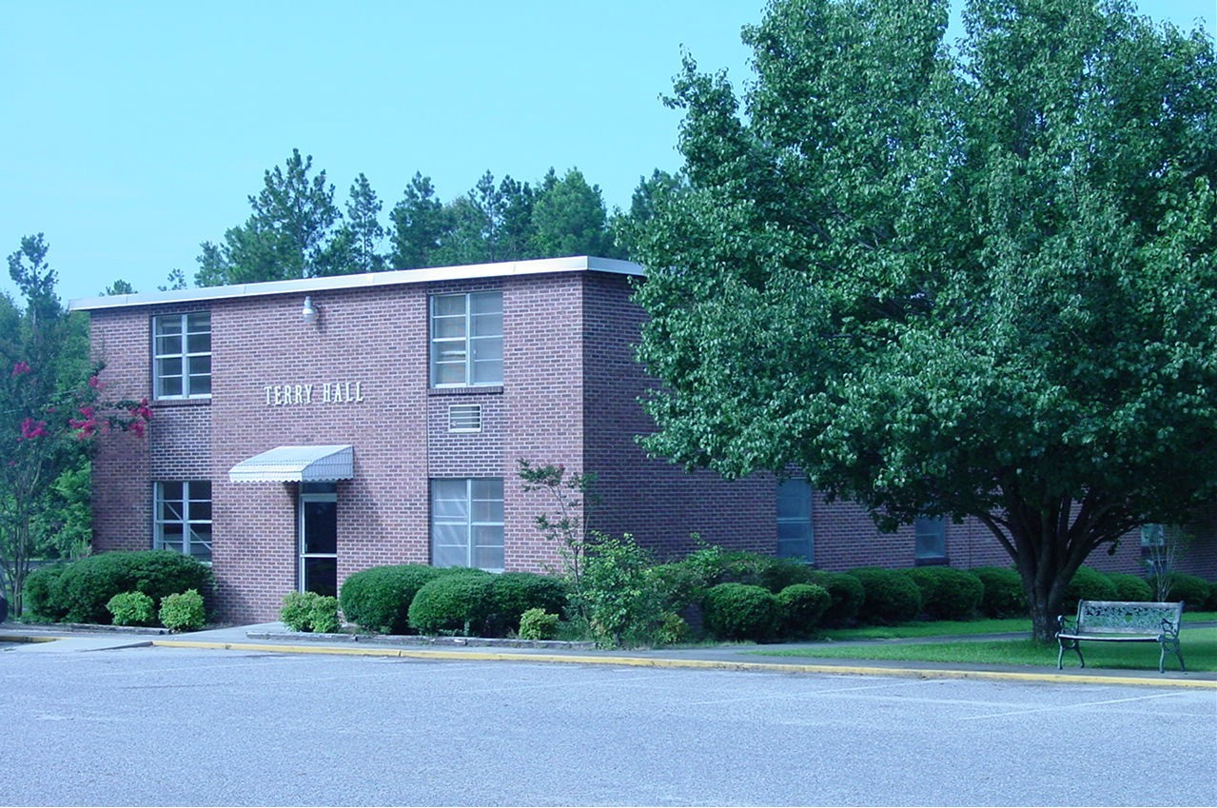
Terry Hall

